

Bachelor of Computer Applications (BCA) Programme

Project Report

BCA Sem VI

AY 2020-21

*The TajMahal Beverages (E-Commerce Website)*

*by*

|  |  |
| --- | --- |
| Exam No. | Name of Student |
| 3253 | Patrawala Mohammed Abbasbhai |
| 3280 | Shaikh Aadil Javed |

|  |  |
| --- | --- |
| Project Guide by : | |
| Prof. Nainesh Gathiyawala |  |



C E R T I F I C A T E

This is to certify that Mr. **Shaikh Aadil Javed, Patrawala Mohammed Abbasbhai** examination number **3280, 3253** has satisfactorily completed his project work entitled **The Tajmahal Beverages (E-Commerce Website)** as partial fulfillment of requirements for BCA Sem VI, during the academic year 2020-21.

|  |  |
| --- | --- |
| Date: 17/06/2021 |  |
| Place: Surat | Dr. Aditi Bhatt  (I/c Principal)  SDJ International College,  Surat |

**Acknowledgement**

The success and final outcome of this project required a lot of guidance and assistance from many people and I am extremely fortunate to have got this all along the completion of my Project work. Whatever I have done is only due to such guidance and assistance and I would not forget to thank them.

I owe our profound gratitude to our Director Mr. Deepak Vaidya, Coordinator Mrs. Aditi Bhatt, HOD Dr. Vaibhav Desai and Project guides Assistant Prof. **Nainesh Gathiyawala** of SDJ International College, who took keen interest on my Project work and guided me all along, till the completion of my Project work by providing all the necessary information for presenting a good Concept. I am extremely grateful to them for providing such a nice support and guidance though they had busy schedule managing the college affairs.

I am thankful and fortunate enough to get support and guidance from all Teaching staffs of Bachelor of Computer Application Department which helped me in successfully completing my Project work. Also, I would like to extend my sincere regards to all the non-teaching staff of Bachelor of Computer Application Department for their timely support.

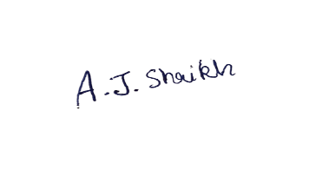

Shaikh Aadil Javed 3280

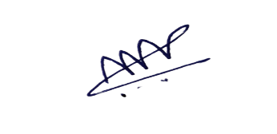

Patrawala Mohammed Abbasbhai

3253

*I N D E X*

|  |  |  |
| --- | --- | --- |
| **Sr No** | **Description** | **Page No.** |
| 1 | Introduction | 2 |
|  | 1.1 Project Summary | 3 |
|  | 1.2 Project Technical Profile | 4 |
|  | 1.3 System Requirements | 5 |
| 2 | Scope & Planning | 6 |
|  | 2.1 Requirement Analysis | 7 |
|  | 2.2 Feasibility Study | 8 |
|  | 2.3 Timeline Chart | 9 |
|  | 2.4 Future Development | 10 |
|  | 2.5 Technology Details | 11 |
| 3 | Designing | 12 |
|  | 3.1 Data Flow Diagram | 13 |
|  | 3.2 Use Case Diagram | 25 |
|  | 3.3 ER Diagram | 28 |
|  | 3.4 Database Dictionary | 29 |
|  | 3.5 Database Design | 33 |
|  | 3.6 User Interface | 38 |
| 4 | Testing | 64 |
|  | 4.1 Unit Testing | 65 |
|  | 4.2 Navigation Testing | 67 |
|  | 4.3 Functional Testing | 68 |
|  | 4.4 Environment Testing | 69 |
| 5 | Conclusion | 70 |
| 6 | Bibliography | 71 |

**1 . INTRODUCTION**

* 1. **Project Summary**

The TajMahal Beverages is a web application, which retails a wide range of Syrups, Beverage Bottle, Flavored Beverages, Sharbat, etc.

This project allows viewing various products available enables registered users to purchase desired products instantly using Online payment (Instant Pay) and also can place orders by using Cash on Delivery (Pay Later) option.

This project provides easy access to Administrators to view orders placed Using Pay Later and Instant Pay options.

To develop an E-Commerce website, several Technologies must be studied and understood. These include multi-tiered architecture, server, and client-side scripting techniques, implementation technologies such as ASP.NET, programming language (such as C#), and relational databases.

This is a project with the objective to develop a basic website where a consumer is provided with a shopping cart application where users can purchase a product and also know about the technologies used to develop such an application.

This document will discuss each of the underlying technologies to create and implement an E-Commerce Website.

**1.2 Project Technical Profile**

|  |  |
| --- | --- |
| Field | Description |
| Project Title | The TajMahal Beverages |
| Developed For | The TajMahal Beverages |
| Language | C#.Net. |
| Front End | Microsoft Visual Studio 2012. |
| Back End | Microsoft SQL Server 2008. |
| Documentation **Tool** | Microsoft Word 2016,  Wondershare EdrawMax |
| Team Members | 2 Members. |
| Project Duration | 4 Months. |
| Internal Guide | Mr. Nainesh Gathiyawala |
| Name of College | SDJ International College |
| Submitted By | Aadil Shaikh(3280)  Mohammed Patrawala(3253) |

**1.3 System Requirements**

The Tajmahal Beverages requires following technical specifications to run it properly and efficiently.

* **Hardware Requirements:**
* Intel dual core processor or higher.
* 4GB RAM
* 1GB empty space on hard disk.
* Working Internet connection.
* **Software Requirements:**
* Windows 7 or Higher.
* .Net Framework 4.0 or above.
* (No SQL server is required as it has cloud based database.)

2. Scope & Planning

**2.1 Requirement Analysis**

* **Requirement Analysis :-**
* Requirement analysis bridges the gap between system engineering and system design.
* Requirement analysis allows the software engineer to refine the software allocation and build models of data, function and behavioural domains that will be treated by software.
* Requirement analysis provides the software designer with a representation of information, function and behaviour that can be translated to data, architectural interface and component level designs Finally requirement specification provides information to design quality software.
* Requirement analysis also involves studying the current business system to find out how it works and where and improvements are possible
* The process of Requirement analysis is carried out in three steps namely Requirement Anticipation, Requirement Investigation and Requirement Specification are possible.
* **Requirement Anticipation :-**

Requirement Anticipation is very much part of system designing According to our understanding, it is to predict the feature requirement based on the previous experience of user aptitude.

* **Requirement Investigation :-**

Requirement Investigation is the actual study of the system in use currently. Being a manual system, the user interviews, observation, review and course intuition play a major role in fact-finding process. More description about the requirement investigation can be found detail study of the existing system. Also we have done Data Gathering.

* **Requirement Specification :-**

Specification can be a written document, a graphical model, a formal mathematical model, collection usage scenarios. prototype, or any combination of this. It is final product.

**2.2 Feasibility Study**

**An important outcome of preliminary investigation is the determination that the system requested is feasible or not.**

**The feasibility of our project has been judged on the basis of time, technology and finance.**

* **Time :-**
* Project is initiated with specific deadlines.
* We need to determine whether the deadlines are mandatory or desirable.
* Time is one of the most important factors in the development of any system but this kind of feasibility is hardly perfect in the system.
* **Technology :-**
* The system is built on C# Net, which is the latest and highly rated technology for developing desktop application.
* Microsoft SQL Server 2008 is the best suitable Back End.
* So system will be up to the mark according to technology:
* **Finance :-**
* The most important issue in the feasibility study is cost benefits analysis. The cost involved in the designing and developing a system should be good investment for the organization, the financial benefits must be justified by the cost.
* The finance and economical issues raised during preliminary investigations are as follow. There is no extra cost of hardware.

**2.3 Time Line Chart**

|  |  |  |  |  |  |  |  |  |  |  |  |  |  |  |  |  |  |  |  |  |  |  |  |
| --- | --- | --- | --- | --- | --- | --- | --- | --- | --- | --- | --- | --- | --- | --- | --- | --- | --- | --- | --- | --- | --- | --- | --- |
| **Work Tasks** | **Jan** | **Feb** | | | | | **March** | | | | | **April** | | | | **May** | | | | | **June** | | |
| **Week** | **4** | **1** | **2** | **3** | **4** | **1** | | **2** | **3** | **4** | **1** | | **2** | **3** | **4** | | **1** | **2** | **3** | **4** | | **1** | **2** |
| **1.Requirement Gathering**  **Analysis** |  |  |  |  |  |  | |  |  |  |  | |  |  |  | |  |  |  |  | |  |  |
| 1.1 Learn C# |  |  |  |  |  |  | |  |  |  |  | |  |  |  | |  |  |  |  | |  |  |
| 1.2 Requirement Gathering |  |  |  |  |  |  | |  |  |  |  | |  |  |  | |  |  |  |  | |  |  |
| 1.3 Requirement Analysis |  |  |  |  |  |  | |  |  |  |  | |  |  |  | |  |  |  |  | |  |  |
| **Milestone**: Requirements Gathered. |  |  |  |  |  |  | |  |  |  |  | |  |  |  | |  |  |  |  | |  |  |
| **2.Modeling** |  |  |  |  |  |  | |  |  |  |  | |  |  |  | |  |  |  |  | |  |  |
| 2.1 Identifying proposed project profile. |  |  |  |  |  |  | |  |  |  |  | |  |  |  | |  |  |  |  | |  |  |
| 2.2 Identifying Objectives. |  |  |  |  |  |  | |  |  |  |  | |  |  |  | |  |  |  |  | |  |  |
| 2.3 Scope definition. |  |  |  |  |  |  | |  |  |  |  | |  |  |  | |  |  |  |  | |  |  |
| 2.4 Review. |  |  |  |  |  |  | |  |  |  |  | |  |  |  | |  |  |  |  | |  |  |
| **Milestone**: Modeling Completed. |  |  |  |  |  |  | |  |  |  |  | |  |  |  | |  |  |  |  | |  |  |
| **3.System Design** |  |  |  |  |  |  | |  |  |  |  | |  |  |  | |  |  |  |  | |  |  |
| 3.1 Design system flow. |  |  |  |  |  |  | |  |  |  |  | |  |  |  | |  |  |  |  | |  |  |
| 3.2 Database Design. |  |  |  |  |  |  | |  |  |  |  | |  |  |  | |  |  |  |  | |  |  |
| 3.3 Admin Side Design. |  |  |  |  |  |  | |  |  |  |  | |  |  |  | |  |  |  |  | |  |  |
| 3.4 Client Side Design |  |  |  |  |  |  | |  |  |  |  | |  |  |  | |  |  |  |  | |  |  |
| 3.5 Review. |  |  |  |  |  |  | |  |  |  |  | |  |  |  | |  |  |  |  | |  |  |
| **Milestone**: System Design completed |  |  |  |  |  |  | |  |  |  |  | |  |  |  | |  |  |  |  | |  |  |
| **4.Coding** |  |  |  |  |  |  | |  |  |  |  | |  |  |  | |  |  |  |  | |  |  |
| 4.1 Admin Side Coding |  |  |  |  |  |  | |  |  |  |  | |  |  |  | |  |  |  |  | |  |  |
| 4.2 Client Side Coding |  |  |  |  |  |  | |  |  |  |  | |  |  |  | |  |  |  |  | |  |  |
| **Milestone**: Coding completed |  |  |  |  |  |  | |  |  |  |  | |  |  |  | |  |  |  |  | |  |  |
| **5.Testing** |  |  |  |  |  |  | |  |  |  |  | |  |  |  | |  |  |  |  | |  |  |
| 5.1 Unit Testing |  |  |  |  |  |  | |  |  |  |  | |  |  |  | |  |  |  |  | |  |  |
| 5.2 Navigational Testing |  |  |  |  |  |  | |  |  |  |  | |  |  |  | |  |  |  |  | |  |  |
| 5.3 Functional Testing |  |  |  |  |  |  | |  |  |  |  | |  |  |  | |  |  |  |  | |  |  |
| 5.4 Environmental Testing |  |  |  |  |  |  | |  |  |  |  | |  |  |  | |  |  |  |  | |  |  |
| 5.5 Correction |  |  |  |  |  |  | |  |  |  |  | |  |  |  | |  |  |  |  | |  |  |
| **Milestone:** Testing Complete |  |  |  |  |  |  | |  |  |  |  | |  |  |  | |  |  |  |  | |  |  |
| **6. Documentation** |  |  |  |  |  |  | |  |  |  |  | |  |  |  | |  |  |  |  | |  |  |

**2.4 Future Development**

It is not possible to develop a system that makes all the requirements of the user. User requirements keep changing as the system is being used. Some of the future enhancements that can be done to this system are:

* Based on the future security issues, security can be improved using emerging technologies.
* WebApp development is in the process for mobility of the website.
* Shipping tracking module implementing in the website.
* Live support to client.
* Enhancement is to be made for the Mobile View.

**2.5 Technology Details :-**

* **Hardware Requirements:**

Processor : Intel(R) Core (TM) i3 CPU @ 2.30GHz

Memory : 2 GB

Hard Disk :1GB or Higher

* **Software Requirements:**

Operating System : Windows 7 or higher

Frontend : Microsoft Visual Studio 2012

Code Behind : C#

Backend : SQL Server Management Studio 2008

Other Tools : HTML, Java Script, Bootstrap, CSS &

jQuery

Input Device : Keyboard, Mouse

Output Device : Monitor

Browser : All Modern Browsers

**3. Designing**

**3.1 Data Flow Diagram**

**Context Level Data Diagram**

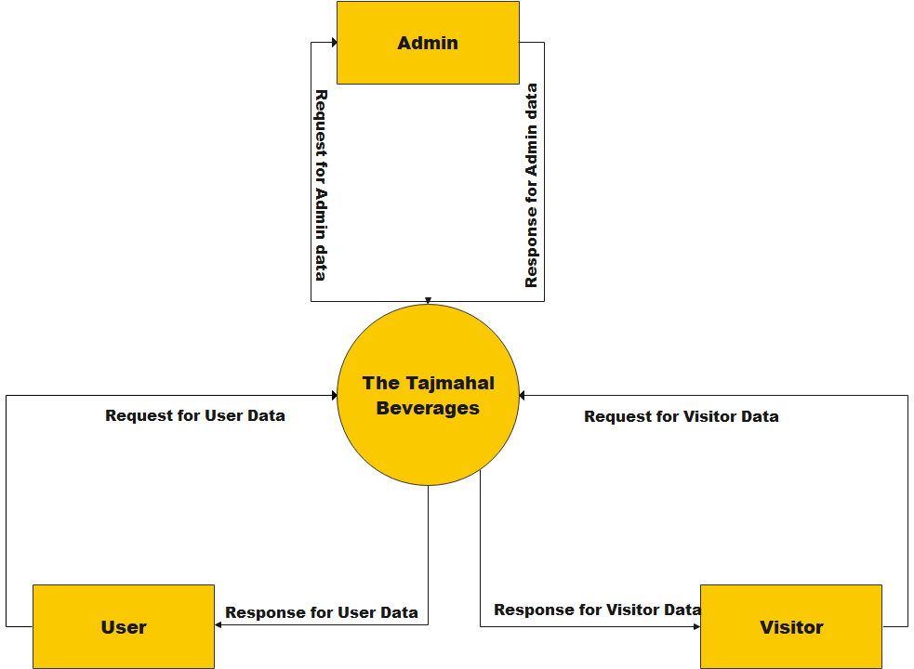

**1st Level Data Flow Diagram**

**1st Level Admin**

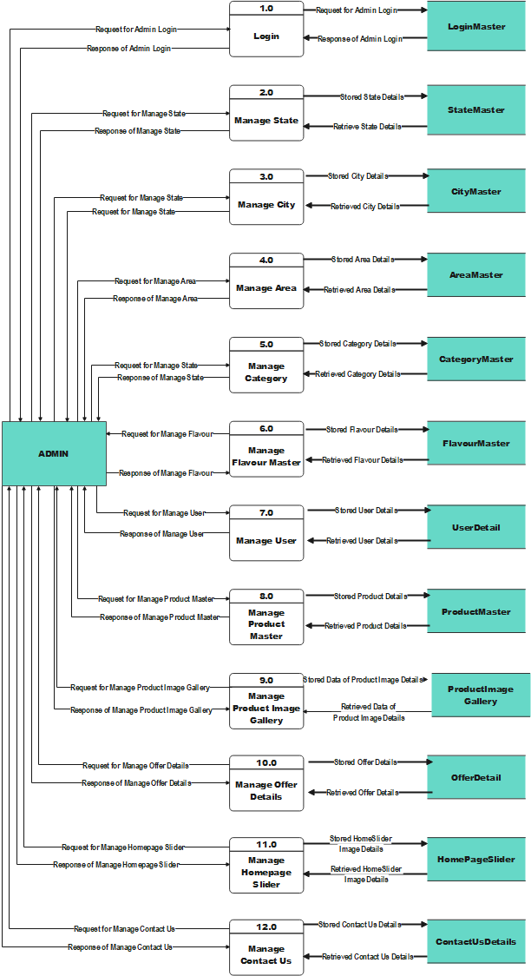

**1st Level Client**

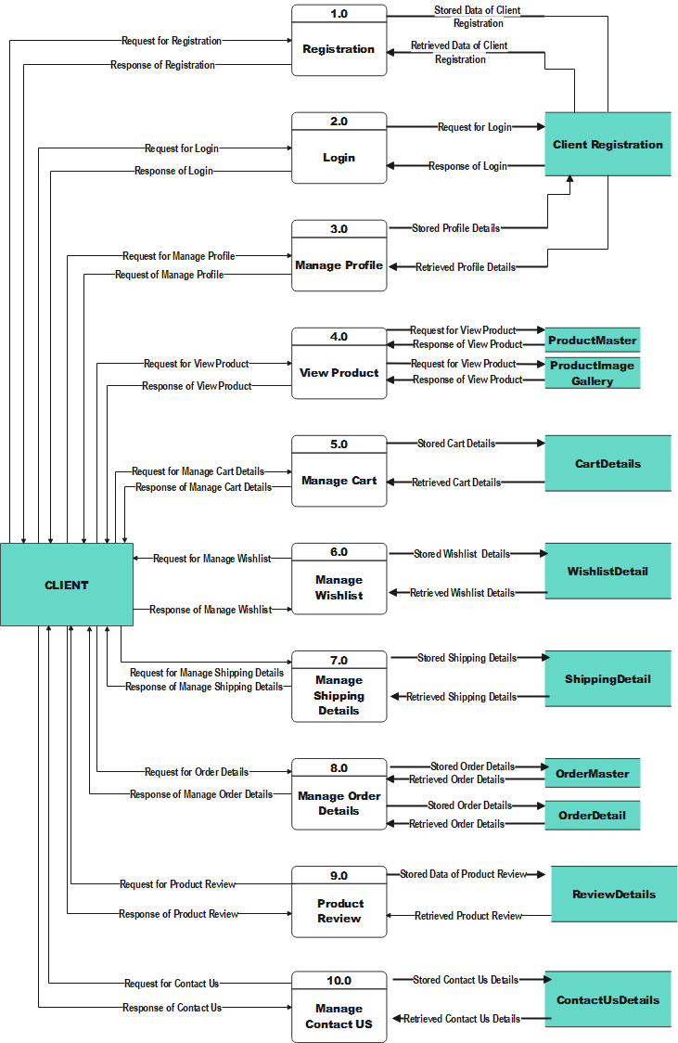

**1st Level Visitor**

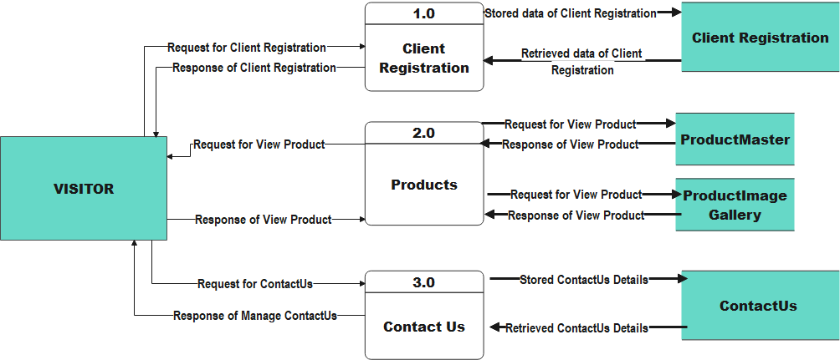

**2nd Level Data Flow Diagram**

**2nd Level Admin (Login)**

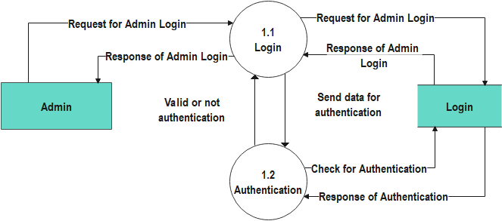

**2nd Level Admin (Manage State)**

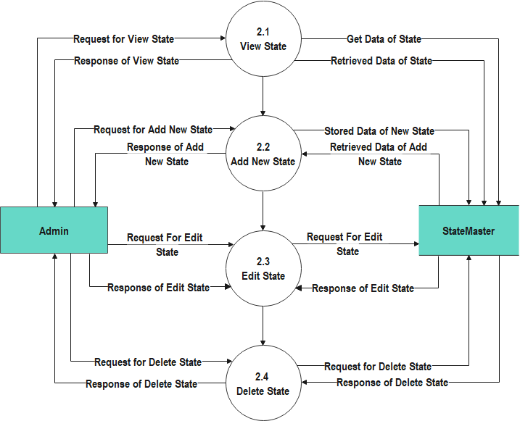

**2nd Level Admin (Manage City)**

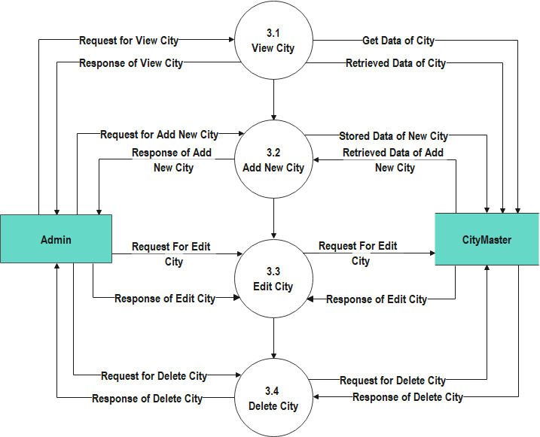

**2nd Level Admin (Manage Area)**

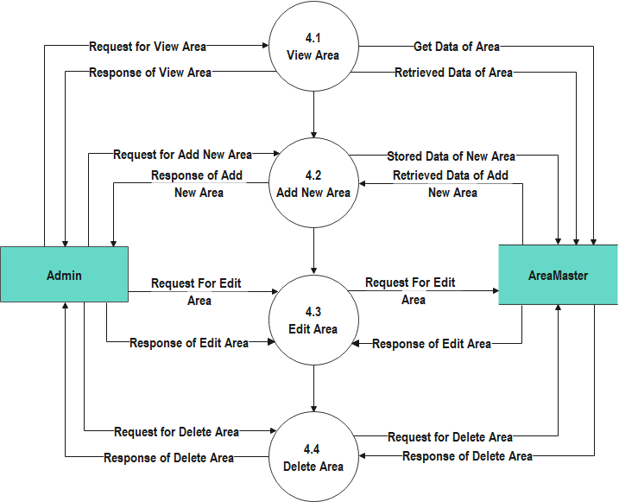

**2nd Level Admin (Manage Category)**

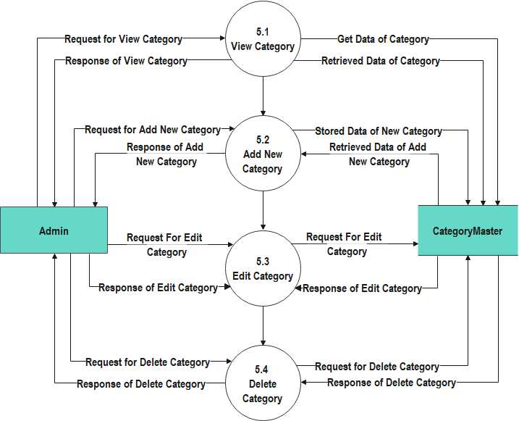

**2nd Level Admin (Manage Flavour)**

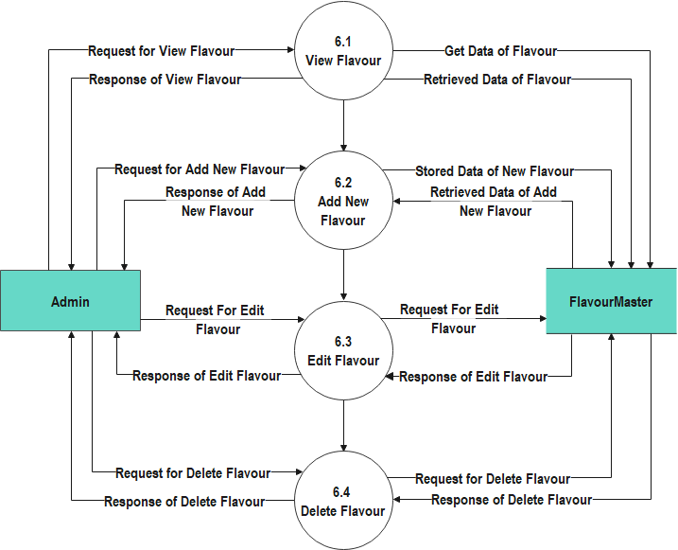

**2nd Level Admin (Manage User)**

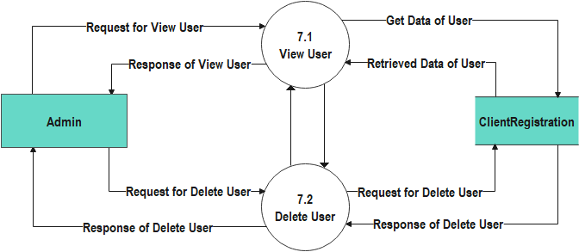

**2nd Level Admin (Manage Inquiry)**

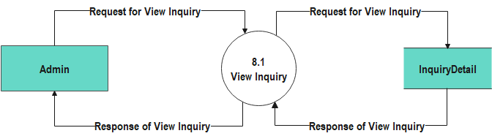

**2nd Level Client (Registration)**

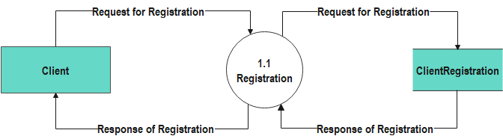

**2nd Level Client (Login)**

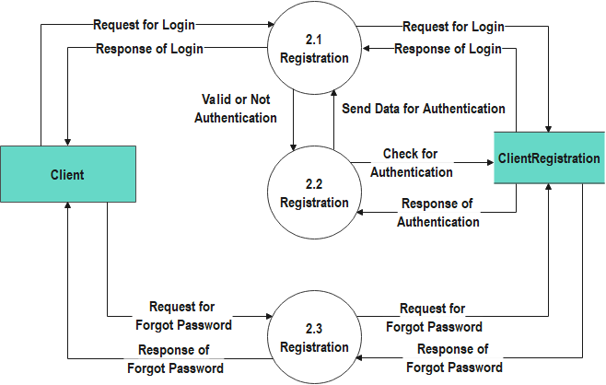

**2nd Level Client (Manage Profile)**

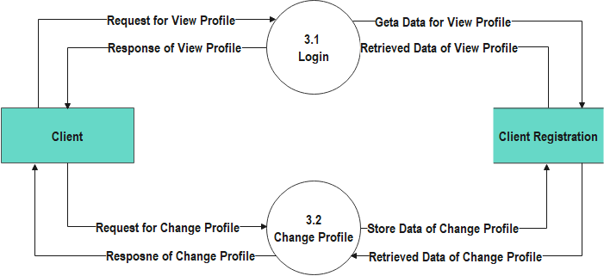

**2nd Level Client (View Product)**

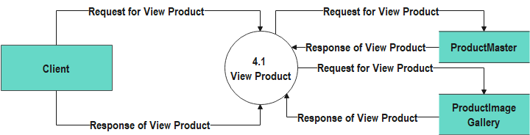

**2nd Level Client (Manage Cart)**

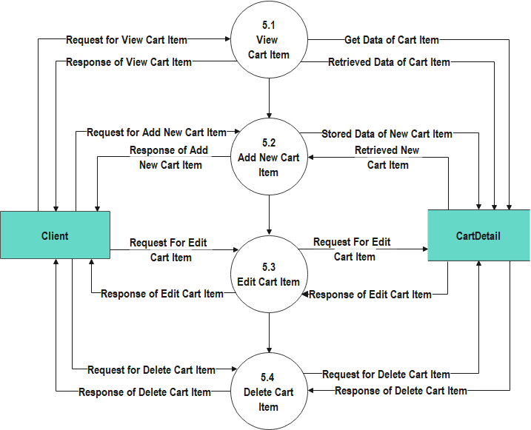

**2nd Level Client (Manage Shipping Details)**

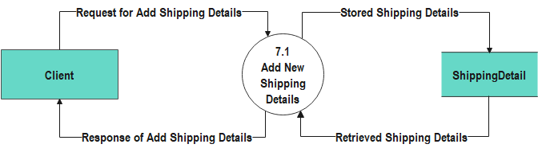

**2nd Level Client (Manage Order Details)**

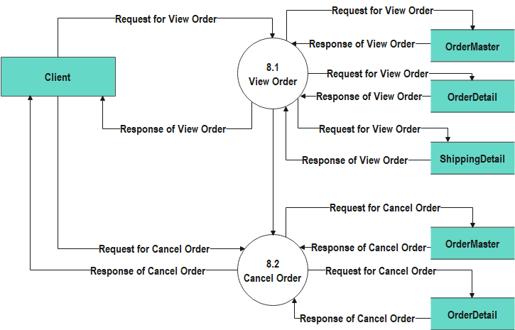

**2nd Level Client (Product Review)**

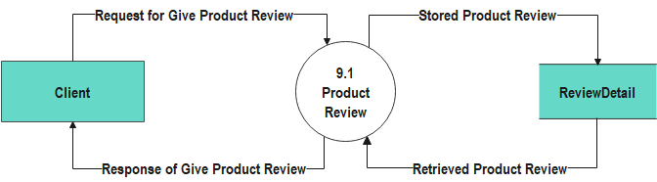

**2nd Level Client (Contact Us)**

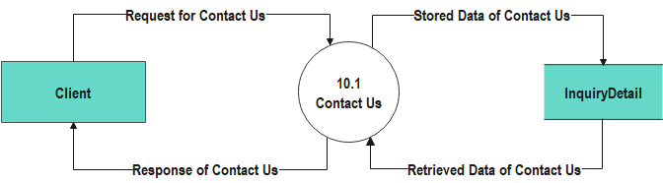

**2nd Level Visitor (Client Registration)**

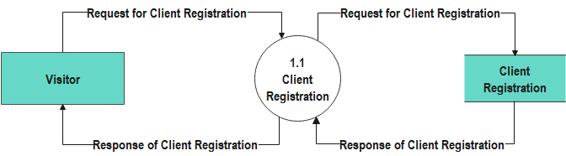

**2nd Level Visitor (View Product)**

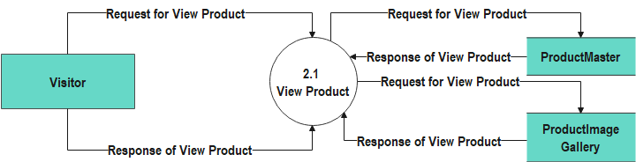

**2nd Level Visitor (Contact Us)**

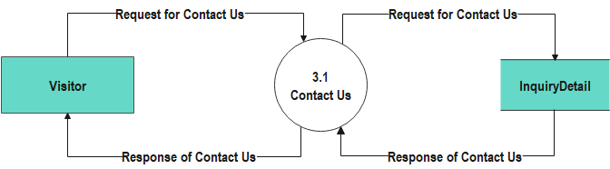

**3.2 Use Case Diagram**

Use case of Admin

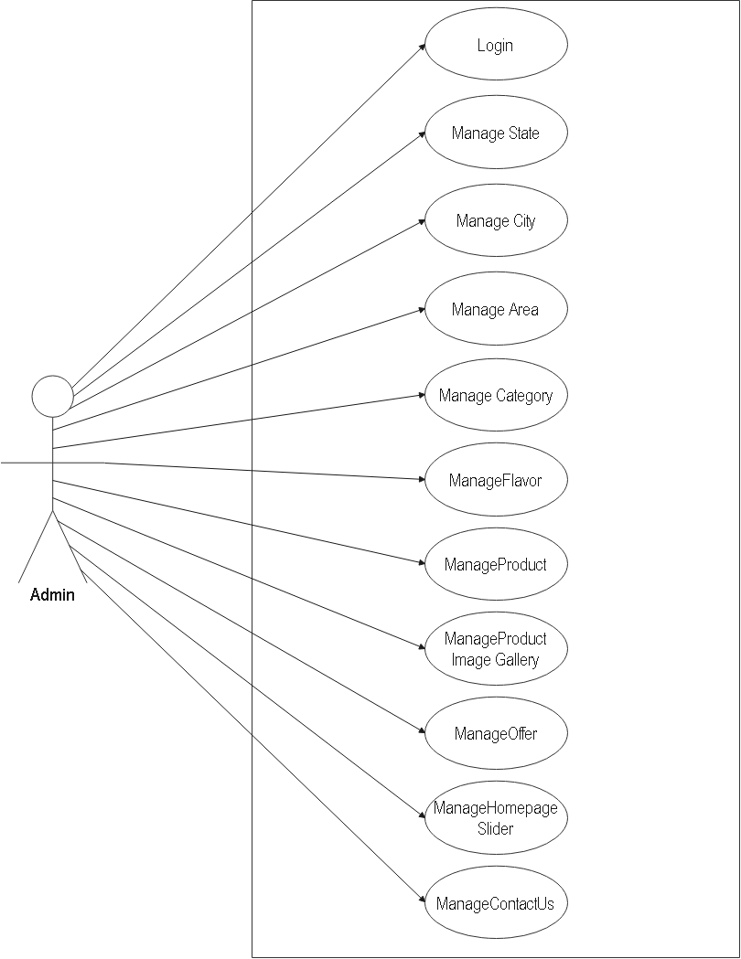

Use case of Client

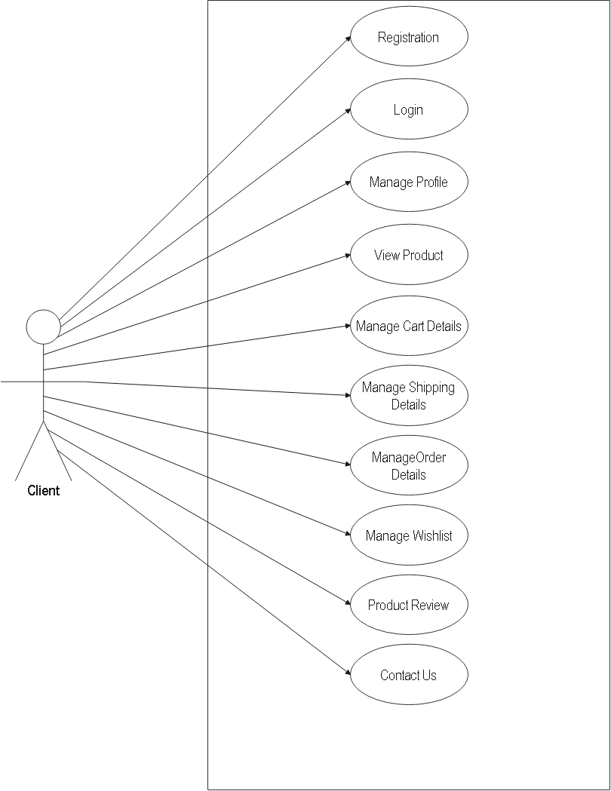

**Use Case of Visitor**

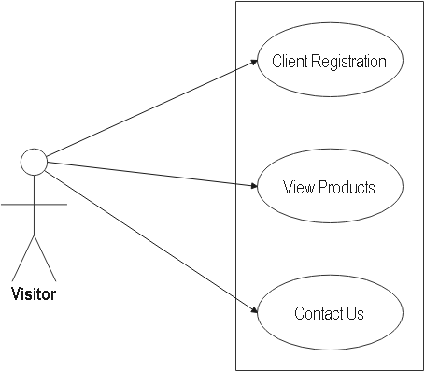

**3.2 Use Case Diagram**

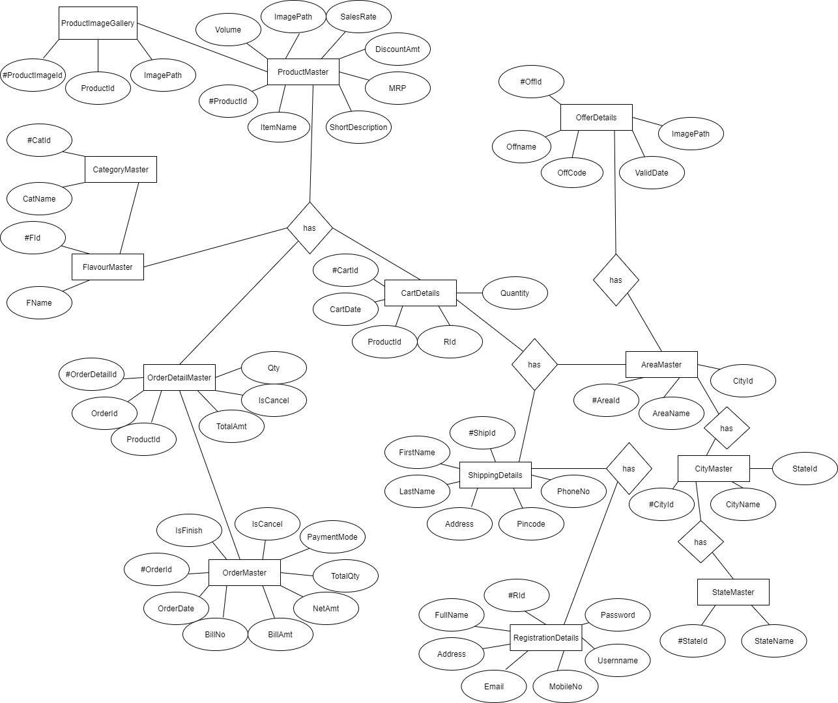

**3.4 Data Dictionary**

|  |  |
| --- | --- |
| **Name :** | **AreaMaster** |
| **Alias :** | **None** |
| **Where How**  **Used :** | **Area Detail Registration Process. (Input)**  **Area Detail Update Process. (Input)**  **Area Detail Delete Process. (Input)**  **Area Detail View Process. (Output)** |
| **Description :** | **Manage Area Details.** |

|  |  |
| --- | --- |
| **Name :** | **CartDetails** |
| **Alias :** | **None** |
| **Where How**  **Used :** | **Cart Details Registration Process. (Input)**  **Cart Details Update Process. (Input)**  **Cart Details Delete Process. (Input)**  **Cart Details View Process. (Output)** |
| **Description :** | **Manage Cart Details.** |

|  |  |
| --- | --- |
| **Name :** | **CategoryMaster** |
| **Alias :** | **None** |
| **Where How**  **Used :** | **Category Detail Registration Process. (Input)**  **Category Detail Update Process. (Input)**  **Category Detail Delete Process. (Input)**  **Category Detail View Process. (Output)** |
| **Description :** | **Manage Category Details.** |

|  |  |
| --- | --- |
| **Name :** | **CityMaster** |
| **Alias :** | **None** |
| **Where How**  **Used :** | **City Registration Process. (Input)**  **City Update Process. (Input)**  **City Delete Process. (Input)**  **City View Process. (Output)** |
| **Description :** | **Manage City Details.** |

|  |  |
| --- | --- |
| **Name :** | **ContactUsDetail** |
| **Alias :** | **None** |
| **Where How**  **Used :** | **ContactUs Detail Registration Process. (Input)**  **ContactUs Detail Update Process. (Input)**  **ContactUs Detail Delete Process. (Input)**  **ContactUs Detail View Process. (Output)** |
| **Description :** | **Manage ContactUs Details.** |

|  |  |
| --- | --- |
| **Name :** | **FlavourMaster** |
| **Alias :** | **None** |
| **Where How**  **Used :** | **Flavour Registration Process. (Input)**  **Flavour Update Process. (Input)**  **Flavour Delete Process. (Input)**  **Flavour View Process. (Output)** |
| **Description :** | **Manage Flavour Details.** |

|  |  |
| --- | --- |
| **Name :** | **HomePageSlider** |
| **Alias :** | **None** |
| **Where How**  **Used :** | **HomePageSlider Image Insert Process. (Input)**  **HomePageSlider Image Update Process. (Input)**  **HomePageSlider Image Delete Process. (Input)**  **HomePageSlider Image View Process. (Output)** |
| **Description :** | **Manage HomePageSlider Images Detail. (Output)** |

|  |  |
| --- | --- |
| **Name :** | **OfferDetail** |
| **Alias :** | **None** |
| **Where How**  **Used :** | **OfferDetail Registration Process. (Input)**  **OfferDetail Update Process. (Input)**  **OfferDetail Delete Process. (Input)**  **OfferDetail View Process. (Output)** |
| **Description :** | **Manage Offer Details.** |

|  |  |
| --- | --- |
| **Name :** | **OrderDetailMaster** |
| **Alias :** | **None** |
| **Where How**  **Used :** | **OrderDetail Registration Process. (Input)**  **OrderDetail Update Process. (Input)**  **OrderDetail Delete Process. (Input)**  **OrderDetail View Process. (Output)** |
| **Description :** | **Manage Order Details.** |

|  |  |
| --- | --- |
| **Name :** | **OrderMaster** |
| **Alias :** | **None** |
| **Where How**  **Used :** | **Order Registration Process. (Input)**  **Order Update Process. (Input)**  **Order Delete Process. (Input)**  **Order View Process. (Output)** |
| **Description :** | **Manage Order Master Details.** |

|  |  |
| --- | --- |
| **Name :** | **ProductImageGalllery** |
| **Alias :** | **None** |
| **Where How**  **Used :** | **Product Image Gallery Registration Process. (Input)**  **Product Image Gallery Update Process. (Input)**  **Product Image Gallery Delete Process. (Input)**  **Product Image Gallery View Process. (Output)** |
| **Description :** | **Manage Product Image Gallery Details.** |

|  |  |
| --- | --- |
| **Name :** | **ProductMaster** |
| **Alias :** | **None** |
| **Where How**  **Used :** | **Product Details Registration Process. (Input)**  **Product Details Update Process. (Input)**  **Product Details Delete Process. (Input)**  **Product Details View Process. (Output)** |
| **Description :** | **Manage Product Master Details.** |

|  |  |
| --- | --- |
| **Name :** | **RegistrationDetails** |
| **Alias :** | **None** |
| **Where How**  **Used :** | **Registration Details Registration Process. (Input)**  **Registration Details Update Process. (Input)**  **Registration Details Delete Process. (Input)**  **Registration Details View Process. (Output)** |
| **Description :** | **Manage Registration Details.** |

|  |  |
| --- | --- |
| **Name :** | **ReviewMaster** |
| **Alias :** | **None** |
| **Where How**  **Used :** | **Review Details Registration Process. (Input)**  **Review Details Update Process. (Input)**  **Review Details Delete Process. (Input)**  **Review Details View Process. (Output)** |
| **Description :** | **Manage Review Details.** |

|  |  |
| --- | --- |
| **Name :** | **ShippingDetails** |
| **Alias :** | **None** |
| **Where How**  **Used :** | **Shipping Details Registration Process. (Input)**  **Shipping Details Update Process. (Input)**  **Shipping Details Delete Process. (Input)**  **Shipping Details View Process. (Output)** |
| **Description :** | **Manage Shipping Details.** |

|  |  |
| --- | --- |
| **Name :** | **StateMaster** |
| **Alias :** | **None** |
| **Where How**  **Used :** | **State Master Registration Process. (Input)**  **State Master Update Process. (Input)**  **State Master Delete Process. (Input)**  **State Master View Process. (Output)** |
| **Description :** | **Manage State Details.** |

|  |  |
| --- | --- |
| **Name :** | **UserDetail** |
| **Alias :** | **None** |
| **Where How**  **Used :** | **UserDetail Registration Process. (Input)**  **UserDetail Update Process. (Input)**  **UserDetail Delete Process. (Input)**  **UserDetail View Process. (Output)** |
| **Description :** | **Manage User Details.** |

**3.5 Database Design**

1. **AreaMaster**

|  |  |  |  |
| --- | --- | --- | --- |
| Field Name | Data Type | Constraints | Description |
| AreaId | **Int** | **Primary Key** | **Area ID** |
| AreaName | **Varchar(50)** | **-** | **Area Name** |
| CityId | **Int** | **Foreign Key** | **City ID** |

1. **CartDetails**

|  |  |  |  |
| --- | --- | --- | --- |
| Field Name | Data Type | Constraints | Description |
| CartId | **BigInt** | **Primary Key** | **Cart ID** |
| CartDate | **Date** | **-** | **Cart Inserted Date** |
| ProductId | **BigInt** | **Foreign Key** | **Product ID** |
| RId | **BigInt** | **Foreign Key** | **Registered UserID** |
| Quantity | **BigInt** | **Foreign Key** | **Product Quantity** |

1. **CategoryMaster**

|  |  |  |  |
| --- | --- | --- | --- |
| Field Name | Data Type | Constraints | Description |
| CatId | **Big Int** | **Primary Key** | **Category ID** |
| CatName | **Varchar(50)** | **-** | **Category Name** |

1. **CityMaster**

|  |  |  |  |
| --- | --- | --- | --- |
| Field Name | Data Type | Constraints | Description |
| CityId | **Int** | **Primary Key** | **City ID** |
| CityName | **Varchar(50)** | **-** | **City Name** |
| StateId | **Int** | **Foreign Key** | **State ID** |

1. **ContactUsDetails**

|  |  |  |  |
| --- | --- | --- | --- |
| Field Name | Data Type | Constraints | Description |
| ContactUsId | **BigInt** | **Primary Key** | **Contact Us ID** |
| PersonName | **Varchar(50)** | **-** | **Person Name** |
| EmailId | **Varchar(50)** | **-** | **Email ID** |
| MobileNo | **Varchar(20)** | **-** | **Mobile No.** |
| Message | **Varchar(500)** | **-** | **Contact Us Message** |

1. **FlavourMaster**

|  |  |  |  |
| --- | --- | --- | --- |
| Field Name | Data Type | Constraints | Description |
| FId | **Int** | **Primary Key** | **Flavour ID** |
| FName | **Varchar(50)** | **-** | **Flavour Name** |

1. **HomePageSlider**

|  |  |  |  |
| --- | --- | --- | --- |
| Field Name | Data Type | Constraints | Description |
| HomeId | **Int** | **Primary Key** | **Home Page Slider ID** |
| ImagePath | **Varchar(400)** | **-** | **Home Page Slider Image Path** |

1. **OfferDetail**

|  |  |  |  |
| --- | --- | --- | --- |
| Field Name | Data Type | Constraints | Description |
| OffId | **BigInt** | **Primary Key** | **Offer ID** |
| OffName | **Varchar(50)** | **-** | **Offer Name** |
| OffCode | **Varchar(50)** | **-** | **Offer Code** |
| ValidDate | **Date** | **-** | **Offer Valid Date** |
| ImagePath | **Varhcar(500)** | **-** | **Offer Image Path** |

1. **OrderDetailMaster**

|  |  |  |  |
| --- | --- | --- | --- |
| Field Name | Data Type | Constraints | Description |
| OrderDetailId | **BigInt** | **Primary Key** | **Order Detail ID** |
| OrderId | **BigInt** | **Foreign Key** | **Order ID** |
| ProductId | **BigInt** | **Foreign Key** | **Product ID** |
| TotalAmount | **Decimal(18,2)** | **-** | **Total Amount** |
| Iscancel | **Bit** | **-** | **Is Cancel** |
| Quantity | **Int** | **-** | **Item Quantity** |

1. **OrderMaster**

|  |  |  |  |
| --- | --- | --- | --- |
| Field Name | Data Type | Constraints | Description |
| OrderId | **BigInt** | **Primary Key** | **Order ID** |
| OrderDate | **Date** | **-** | **Order Date** |
| RId | **BigInt** | **Foreign Key** | **Registration ID** |
| BillNo | **Varchar(50)** | **-** | **Bill Number** |
| BillAmount | **Decimal (18,2)** | **-** | **Bill Amount** |
| NetAmount | **Decimal (18,2)** | **-** | **Net Amount** |
| TotalQty | **Int** | **-** | **Total Quantity** |
| ShipId | **Int** | **Foreign Key** | **Shipping ID** |
| PaymentMode | **Varchar(50)** | **-** | **Payment Mode** |
| IsCancel | **Bit** | **-** | **Is Cancel** |
| IsFinish | **Bit** | **-** | **Is Finish** |

1. **ProductImageGallery**

|  |  |  |  |
| --- | --- | --- | --- |
| Field Name | Data Type | Constraints | Description |
| ProductImageId | **BigInt** | **Primary Key** | **Product Image ID** |
| ProductId | **BigInt** | **Foreign Key** | **Product ID** |
| ImagePath | **Varchar(400)** | **-** | **Product Image Path** |

1. **ProductMaster**

|  |  |  |  |
| --- | --- | --- | --- |
| Field Name | Data Type | Constraints | Description |
| ProductId | **BigInt** | **Primary Key** | **Product ID** |
| ProductName | **Varchar(100)** | **-** | **Item Name** |
| Fid | **Int** | **Foreign Key** | **Flavour ID** |
| CatId | **Int** | **Foreign Key** | **Category ID** |
| ShortDescrption | **Varchar(300)** | **-** | **Item Short Description** |
| MRP | **Decimal(18,2)** | **-** | **Item Price** |
| DiscountAmt | **Decimal(18,2)** | **-** | **Item Discount Rate** |
| SalesRate | **Decimal(18,2)** | **-** | **Sales Rate** |
| ImagePath | **Varchar(400)** | **-** | **Item Image Path** |
| Volume | **Varchar(100)** | **-** | **Item Volume** |

1. **Registration Details**

|  |  |  |  |
| --- | --- | --- | --- |
| Field Name | Data Type | Constraints | Description |
| R_Id | **BigInt** | **Primary Key** | **Registration ID** |
| FullName | **Varchar(500)** | **-** | **Full Name** |
| Address | **Varchar(2000)** | **-** | **Address** |
| Email | **Varchar(250)** | **-** | **Email** |
| MobileNo | **Varchar(20)** | **-** | **Mobile No** |
| Username | **Varchar(200)** | **-** | **Username** |
| Password | **Varchar(200)** | **-** | **Password** |

1. **ShippingDetails**

|  |  |  |  |
| --- | --- | --- | --- |
| Field Name | Data Type | Constraints | Description |
| ShipId | **Int** | **Primary Key** | **Shipping ID** |
| Rid | **Int** | **Foreign Key** | **Registration ID** |
| FirstName | **Varchar(50)** | **-** | **First Name** |
| LastName | **Varchar(50)** | **-** | **Last Name** |
| AreaId | **Int** | **-** | **Area ID** |
| Address | **Varchar(50)** | **-** | **Address** |
| Pincode | **Varchar(10)** | **-** | **Pincode** |
| PhoneNo | **Varchar(20)** | **-** | **Phone Number** |

**15. ReviewMaster**

|  |  |  |  |
| --- | --- | --- | --- |
| Field Name | Data Type | Constraints | Description |
| ReviewId | **Int** | **Primary Key** | **Review ID** |
| ReviewDesc | **Varchar(500)** | **-** | **Review Description** |
| ProductId | **Int** | **Foreign Key** | **Product ID** |
| Rid | **Bigint** | **Foreign Key** | **Registration ID** |

**16. StateMaster**

|  |  |  |  |
| --- | --- | --- | --- |
| Field Name | Data Type | Constraints | Description |
| StateId | **Int** | **Primary Key** | **State ID** |
| StateName | **Varchar(50)** | **-** | **State Name** |

**17. UserDetail**

|  |  |  |  |
| --- | --- | --- | --- |
| Field Name | Data Type | Constraints | Description |
| UserId | **Int** | **Primary Key** | **User ID** |
| UserName | **Varchar(50)** | **-** | **User Name** |
| Password | **Varchar(50)** | **-** | **Password** |

**3.5 User Interface**

**Admin Side**

**Admin Login Page**

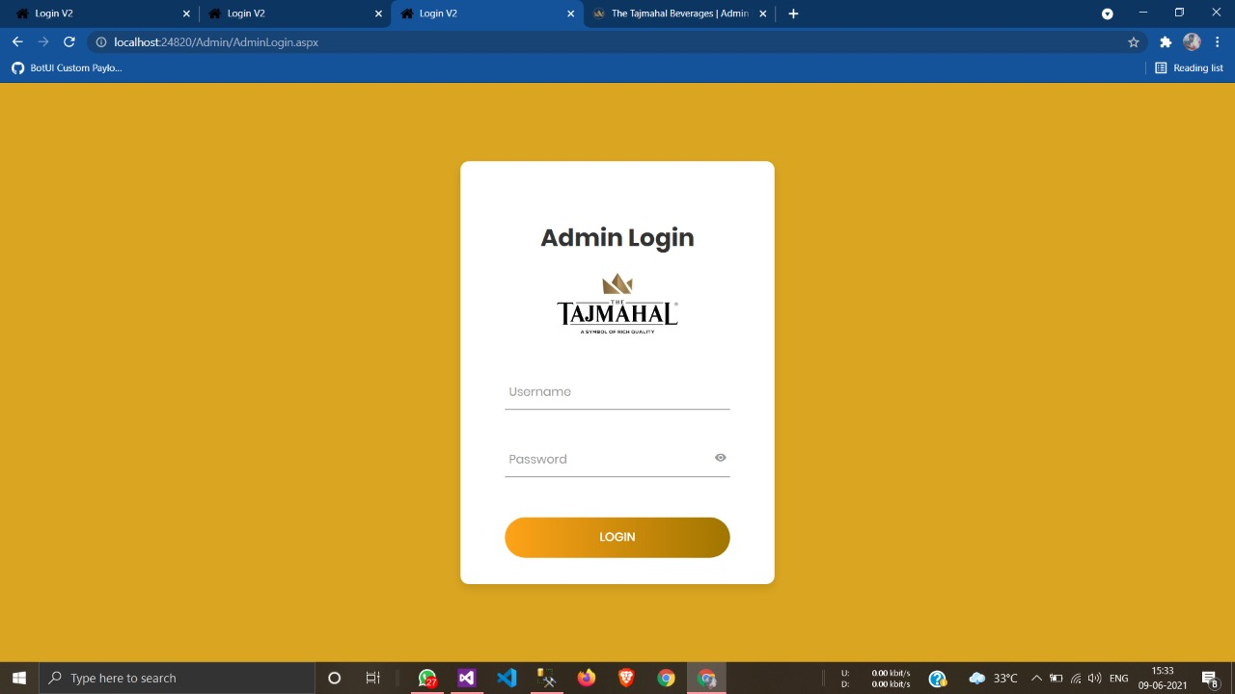

**Validation on Wrong Username or Password**

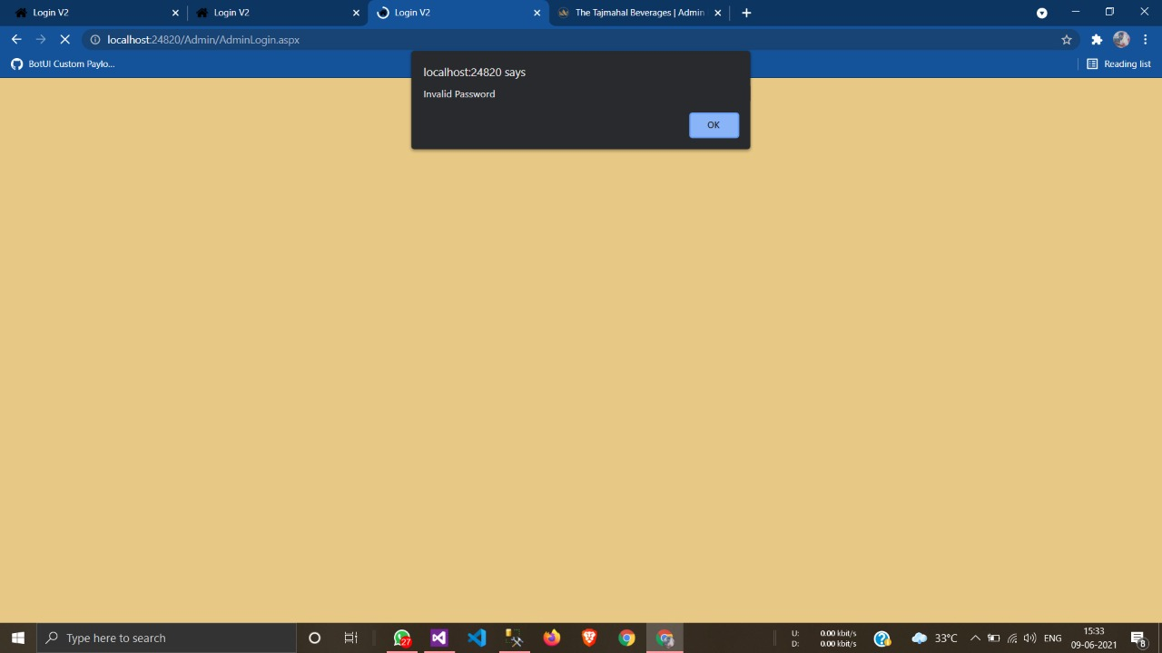

**Admin Dashboard**

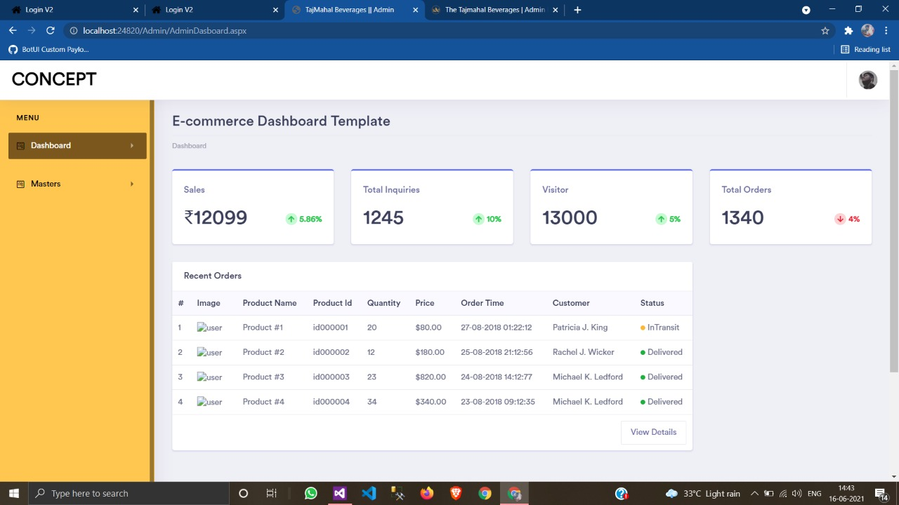

**State Master Page**

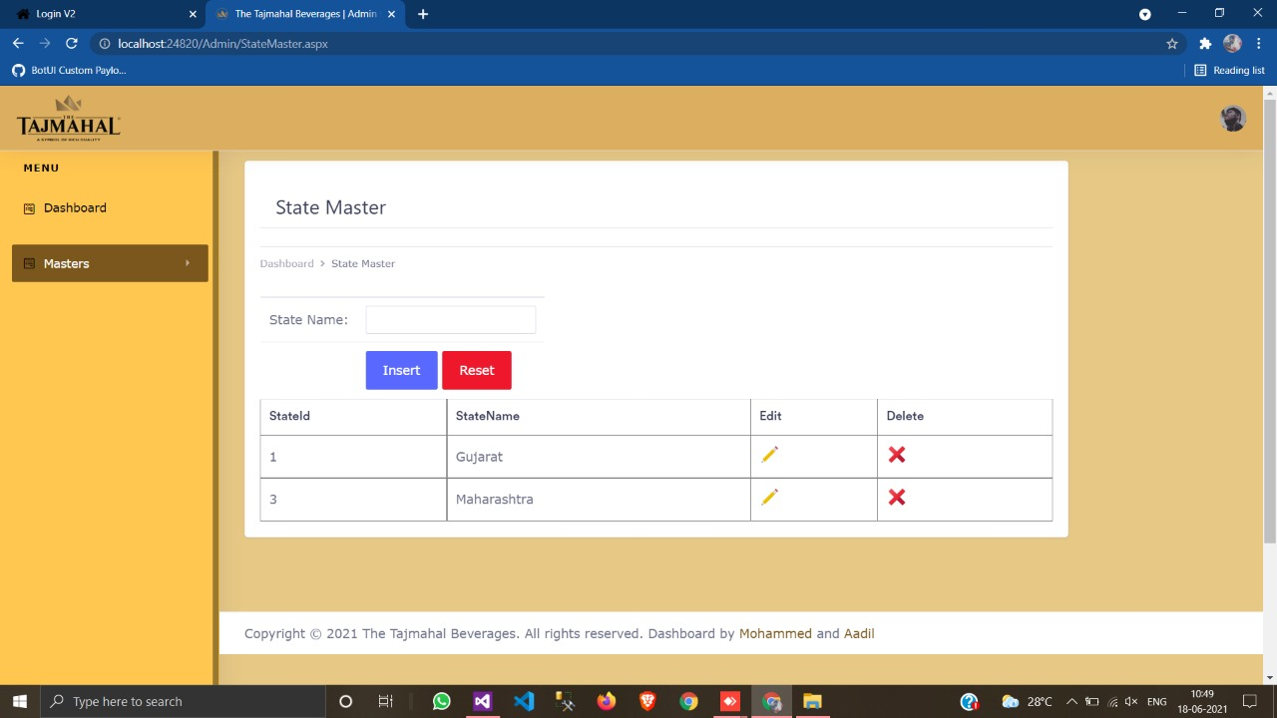

**Check for Empty Field (Validation)**

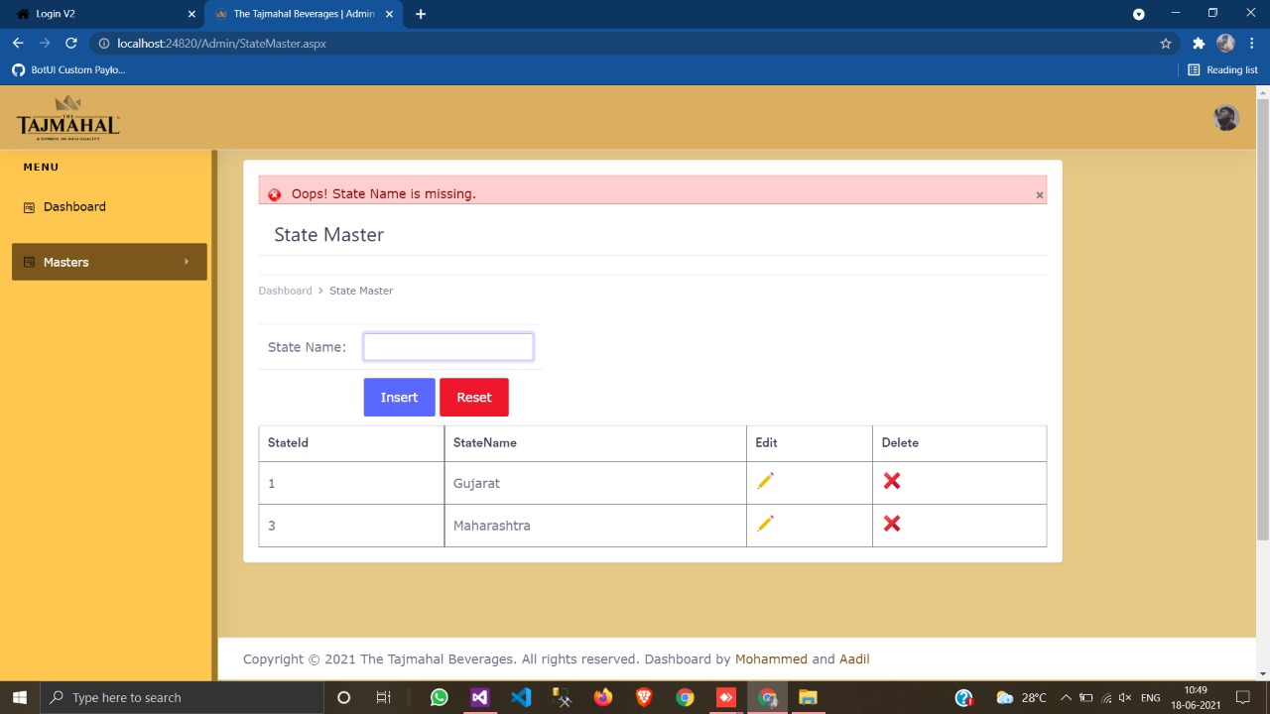

**Check for Existing Record (Validation)**

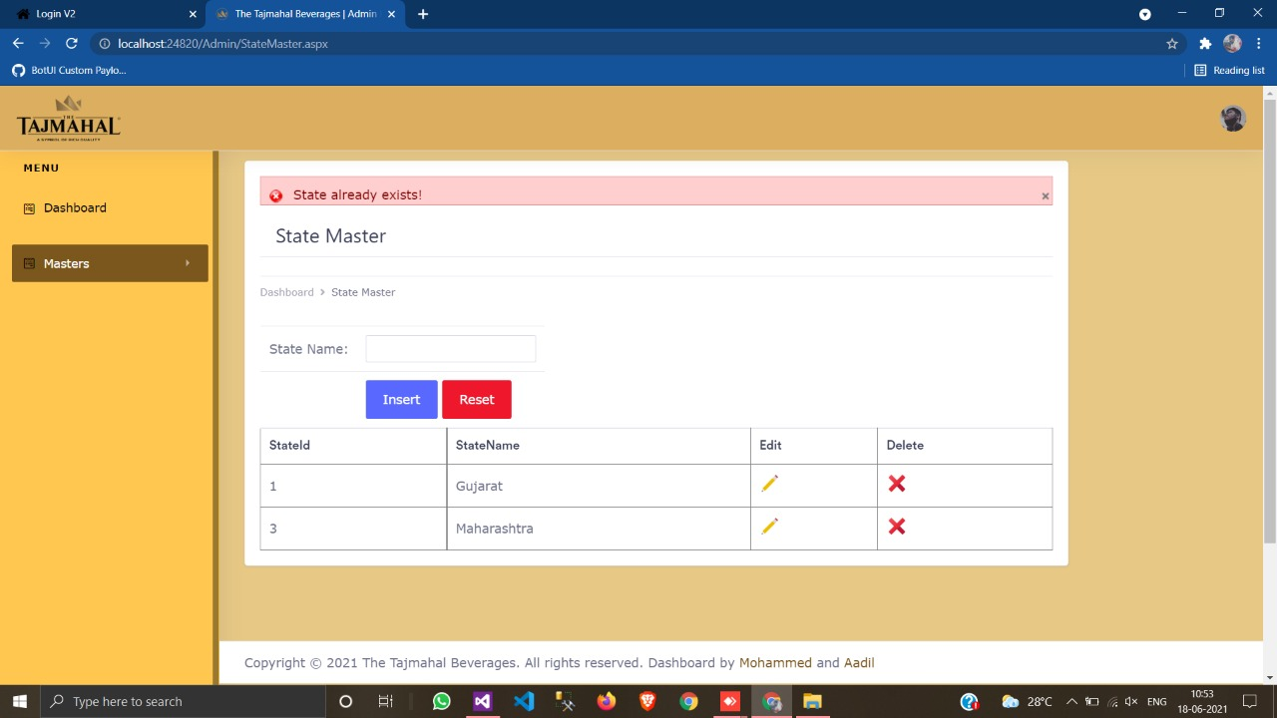

**Message after Data Inserted**

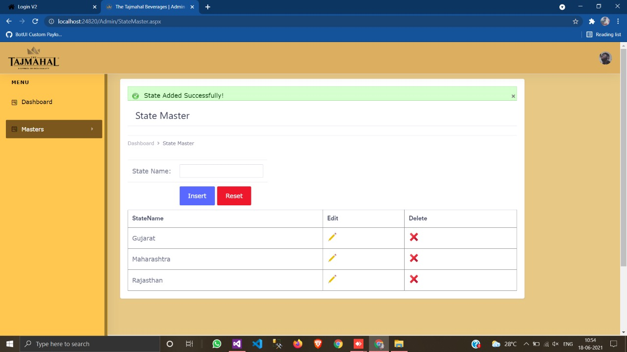

**Edit State Master**

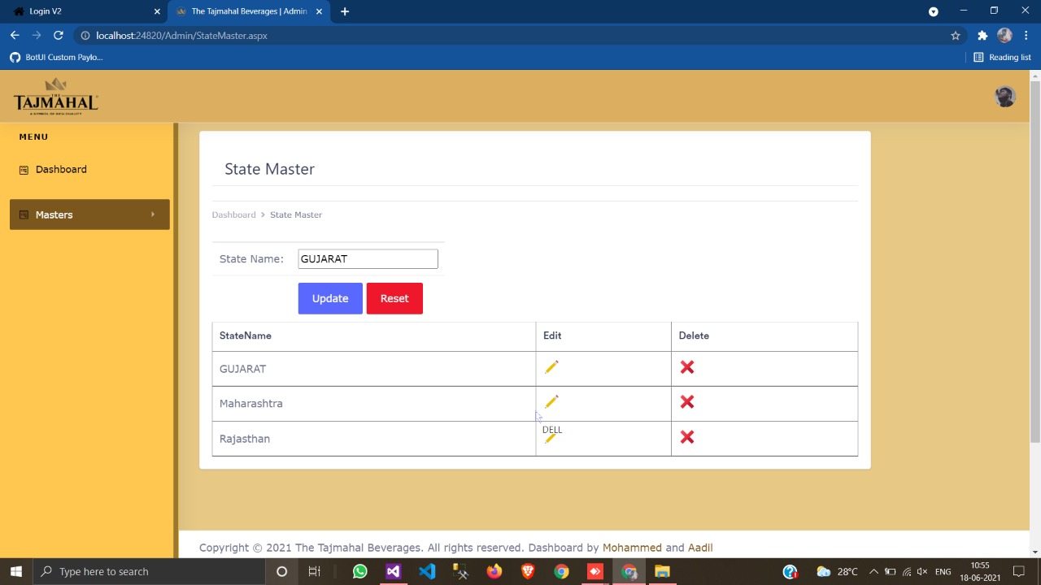

**City Master Page (Add/Edit/Delete with Validation)**

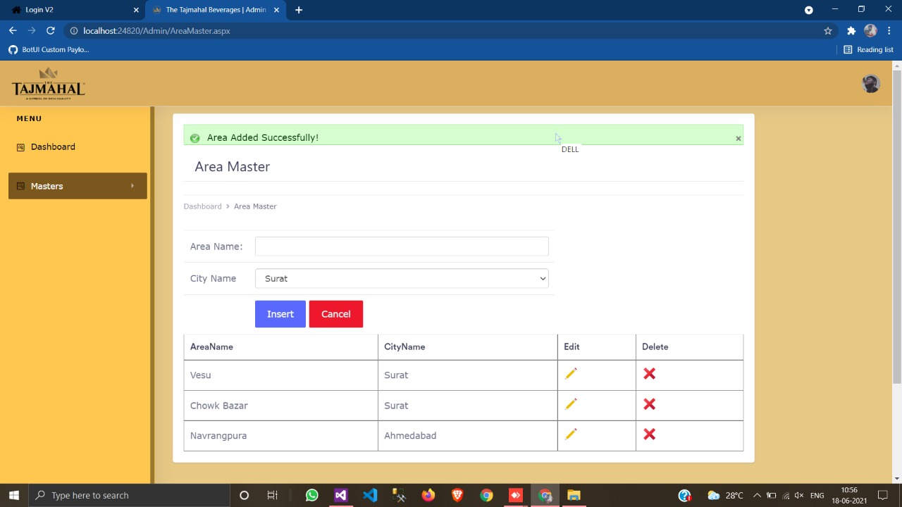

**Area Master Page (Add/Edit/Delete with Validation)**



**Category Master Page (Add/Edit/Delete with Validation)**

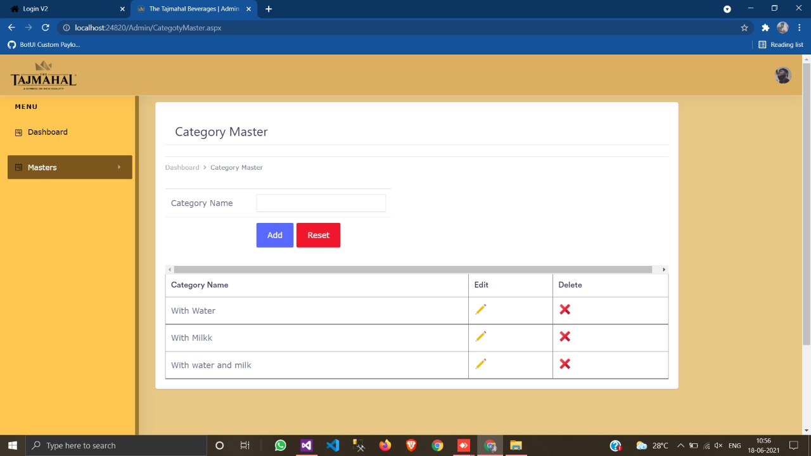

**Flavour Master Page (Add/Edit/Delete with Validation)**

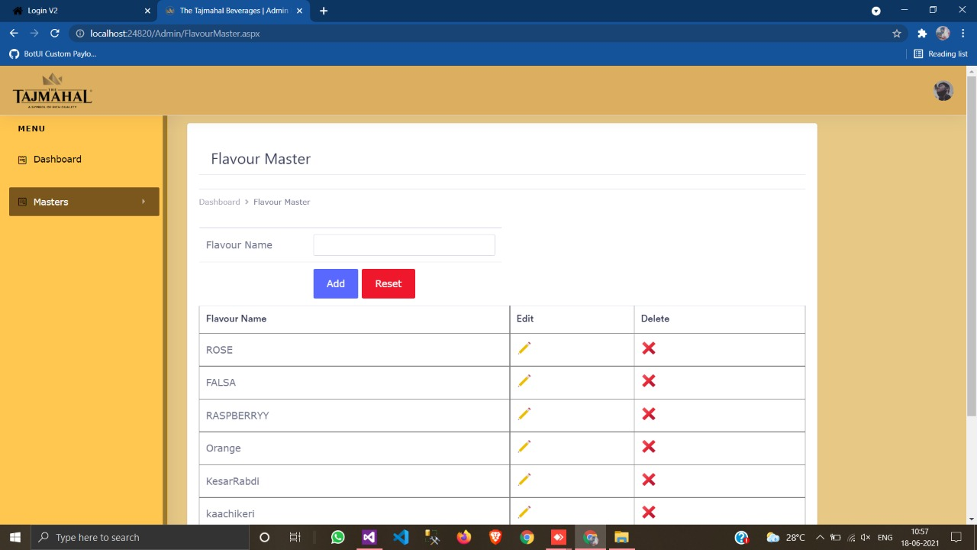

**Offer Detail Page**

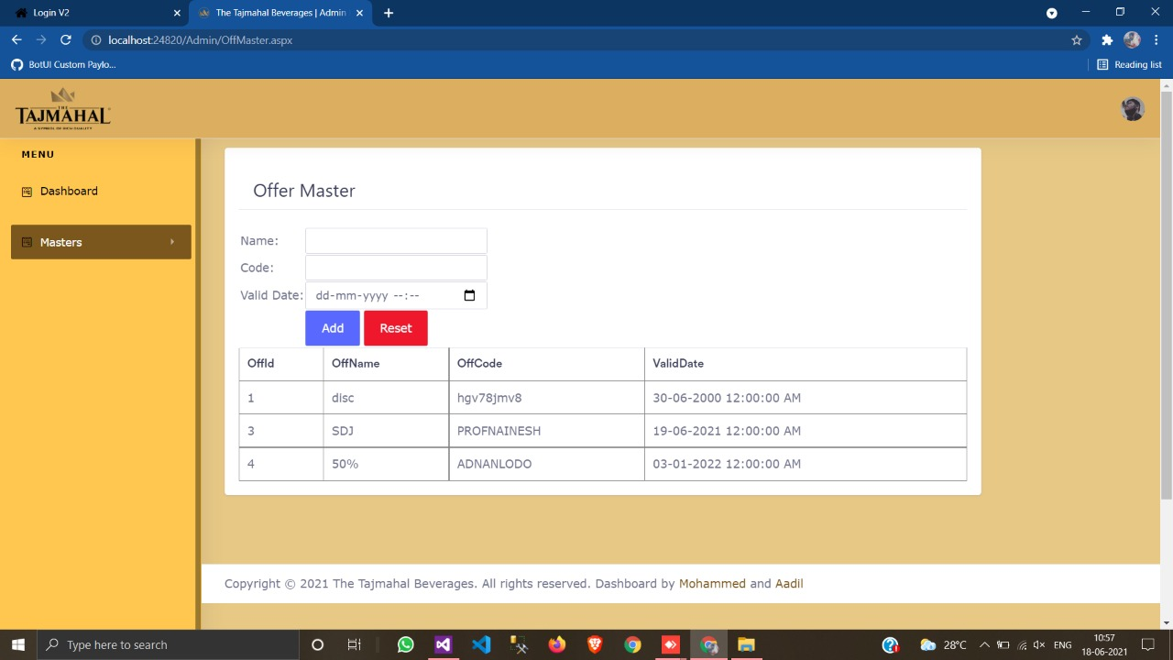

**Contact Us Detail Page**

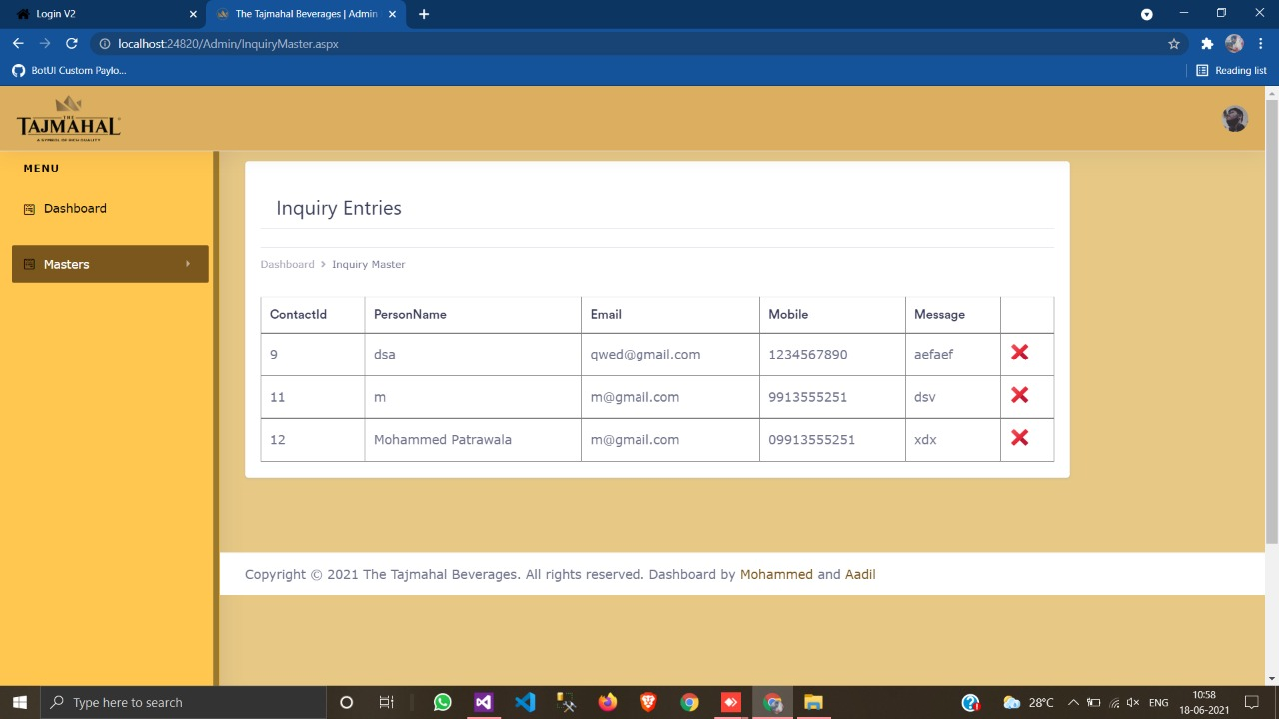

**Client Side**

**Home Page**

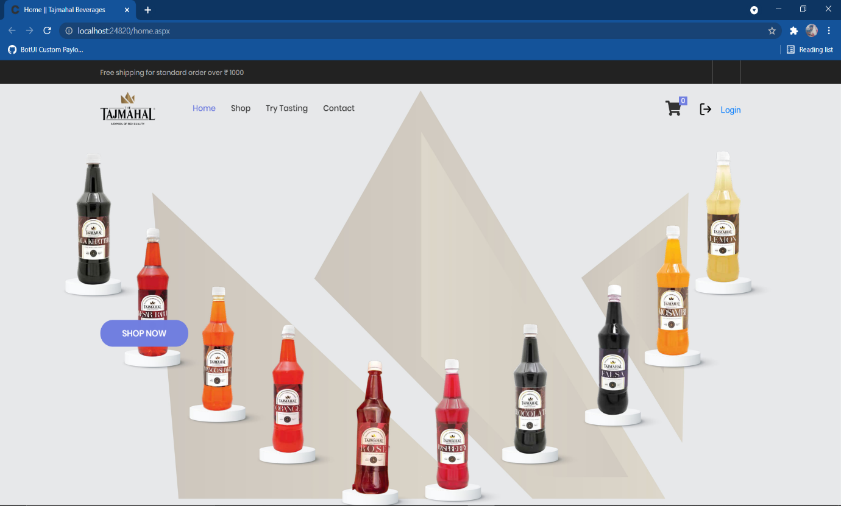

**Shop Page**

* By default It shows all the products.
* User can shop item by different categories & Flavours.

**Grid View of Shop Page**

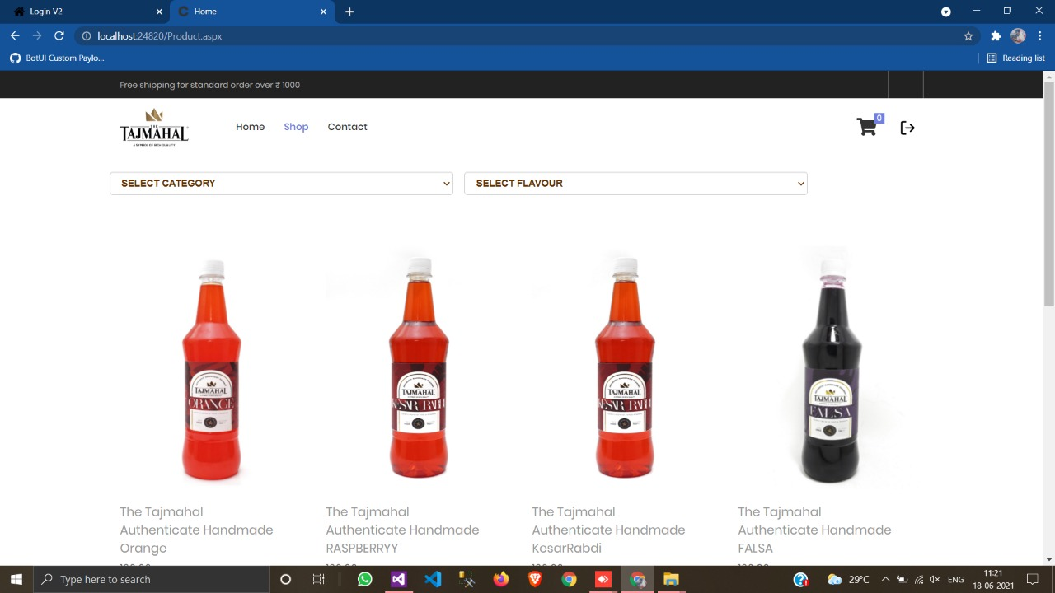

**Shop by Categories**

1. **With Water Category**

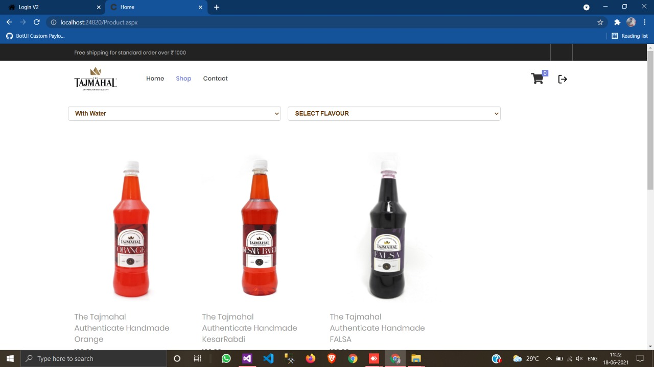

1. **With Milk Category**

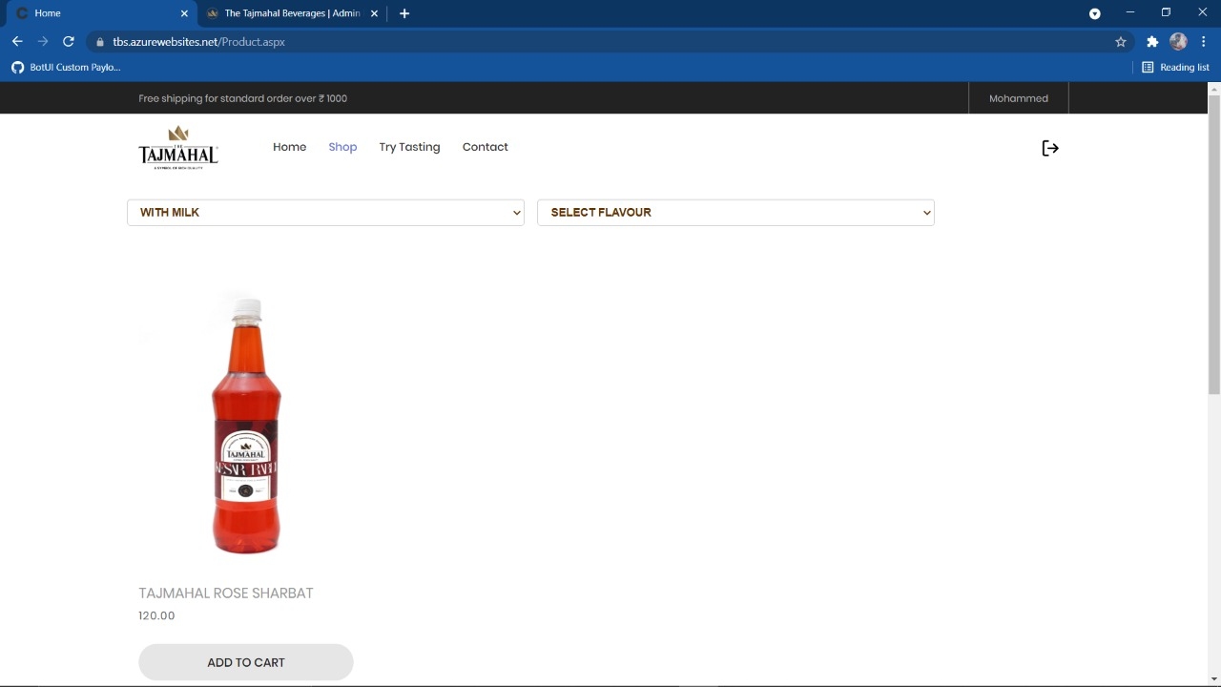

1. **With Water & Milk Category**

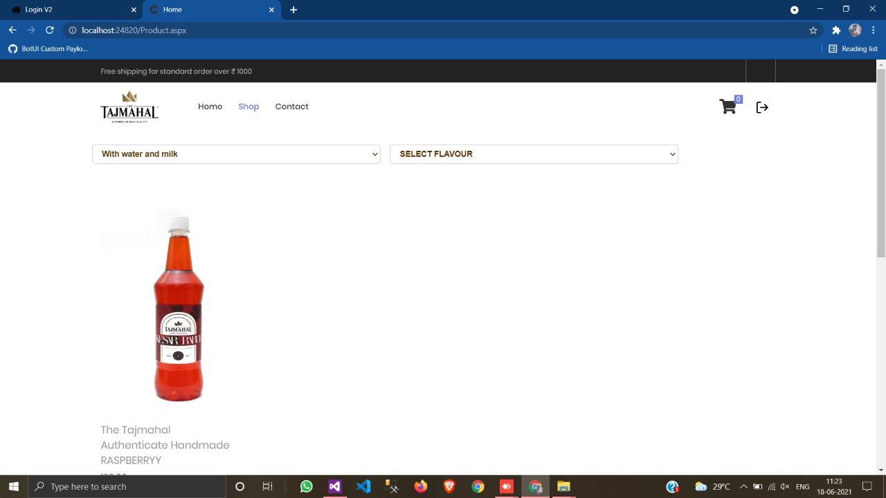

**Product Master Page**

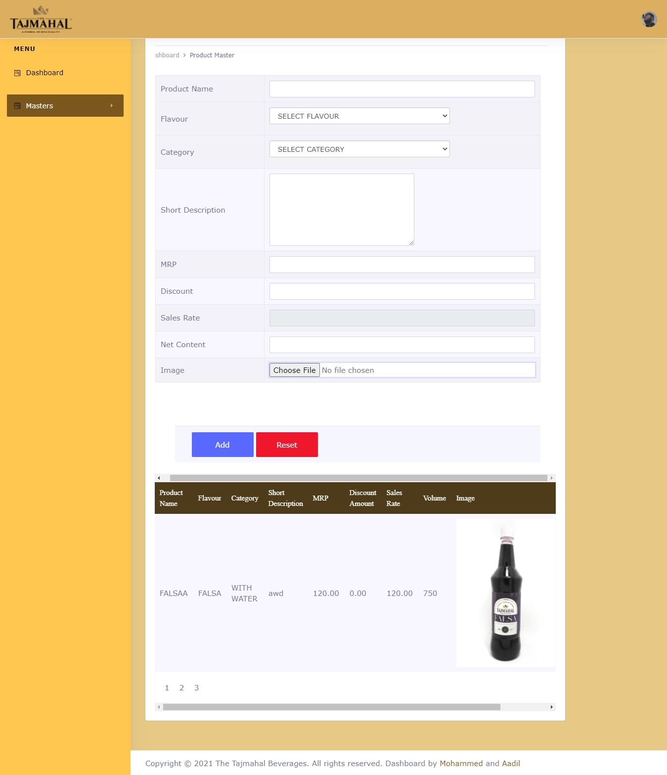

**Add New Item Master**

**Validations:**

1. All fields are required.
2. Product Name only alphabetic allowed.
3. Rate only numbers allowed.
4. Image should be in .jpg, .jpeg, .png, .gif format only.

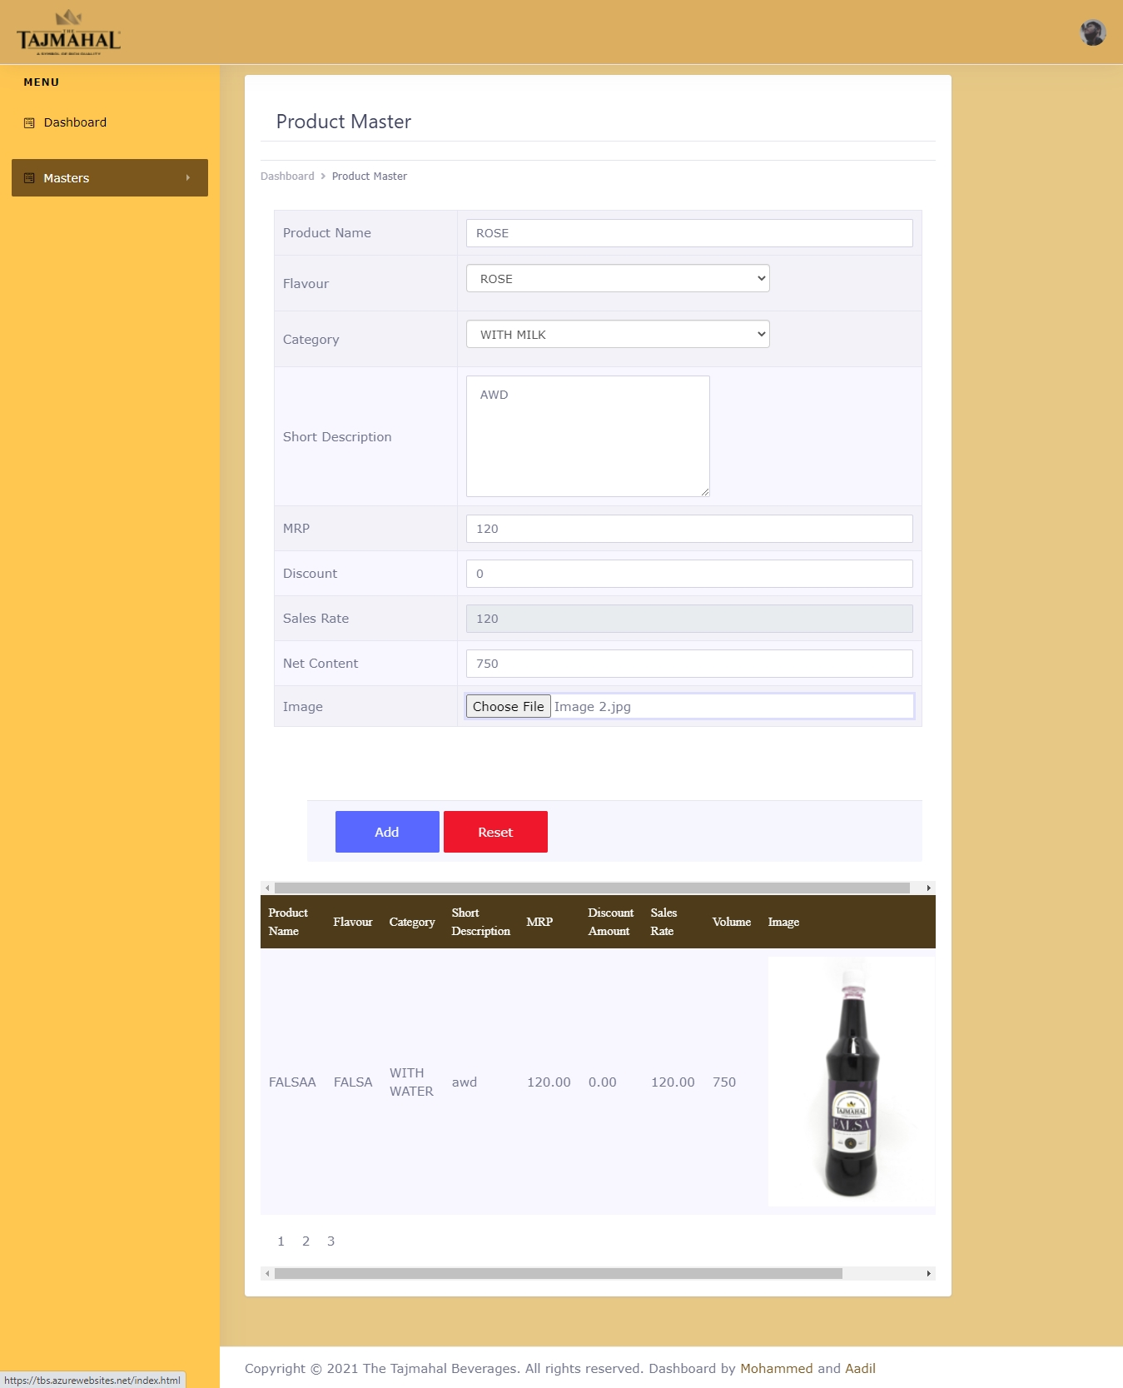

**Message after New Item Inserted**

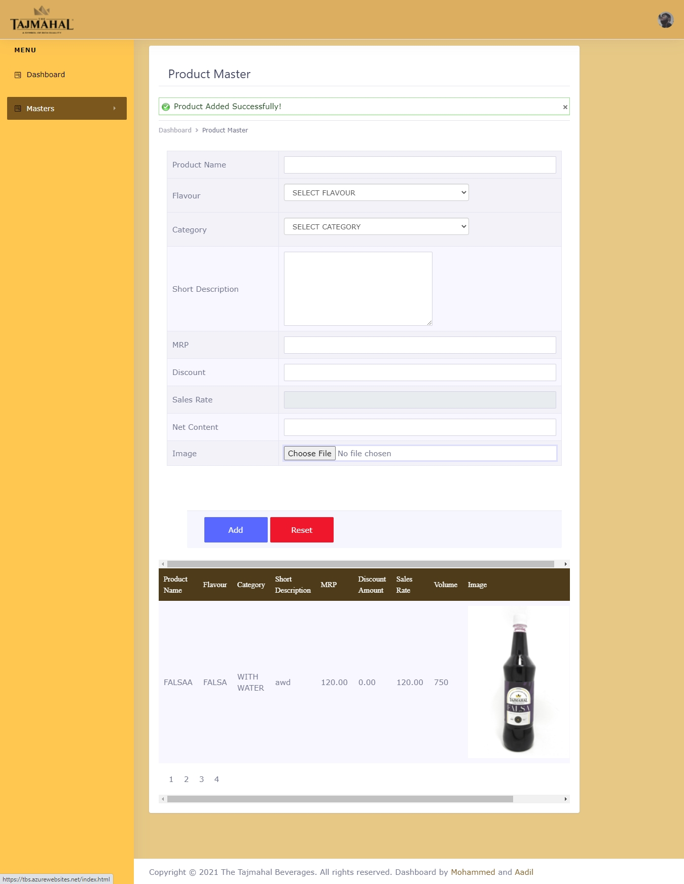

**Contact Us Page**

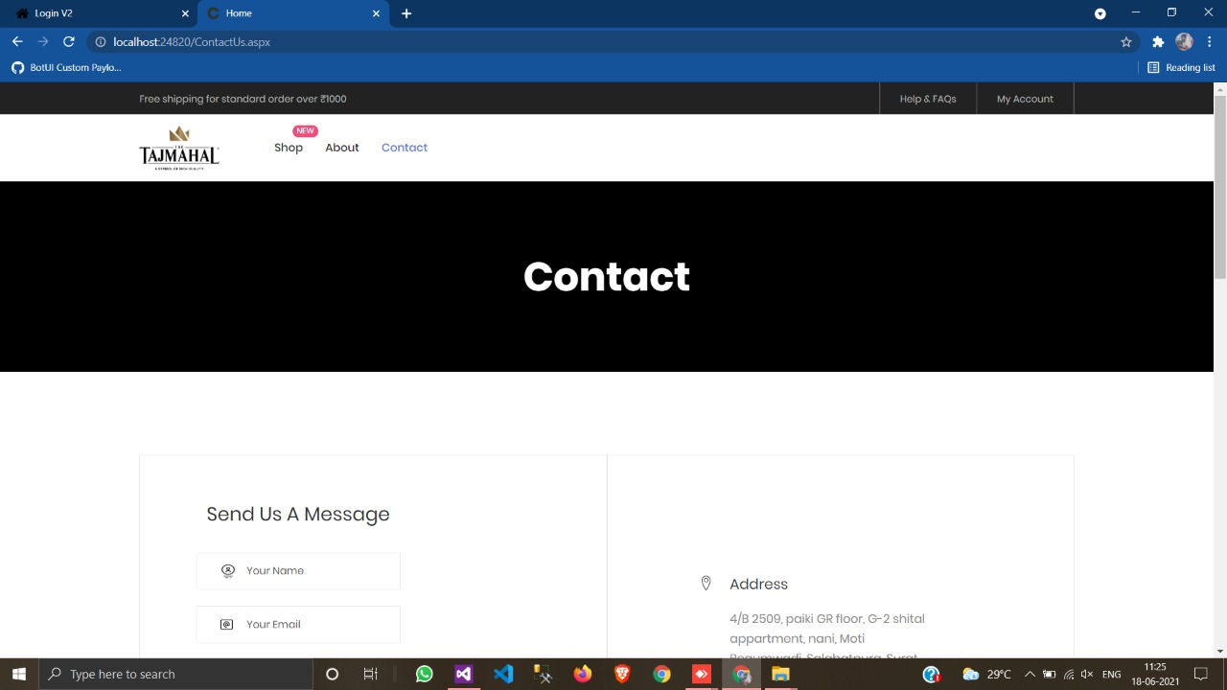

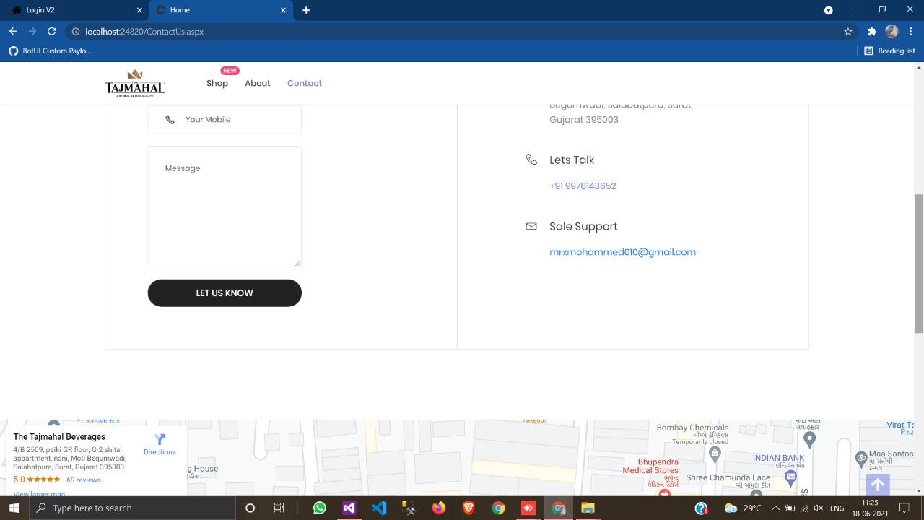

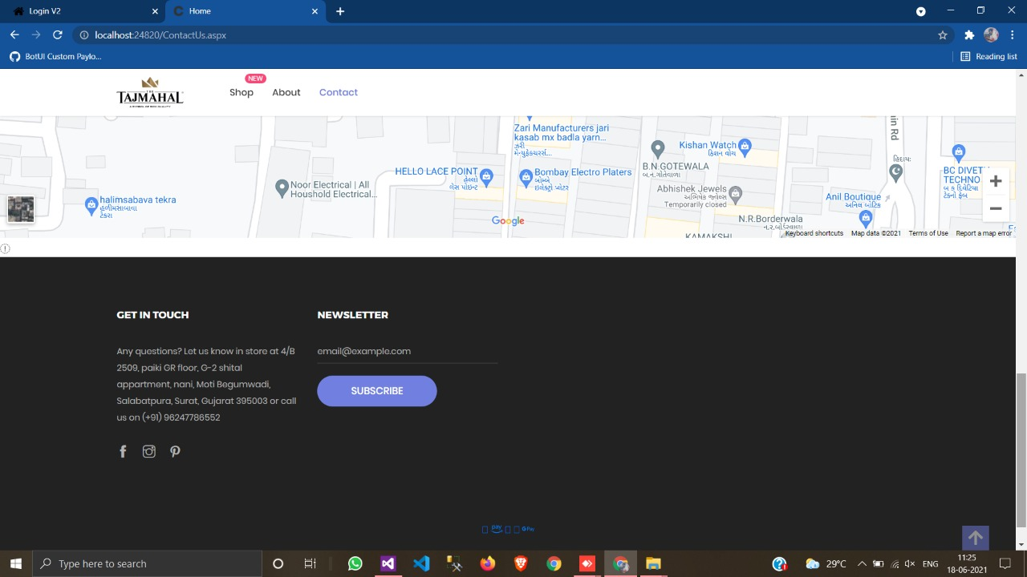

**Required Field Validation on Contact Us Page**

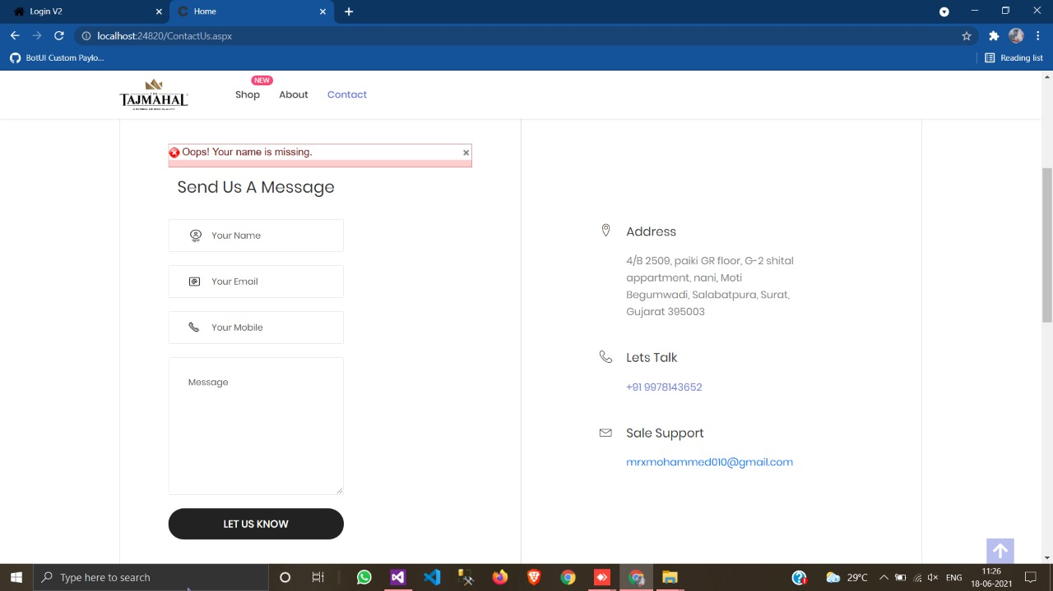

**Client Registration Page**

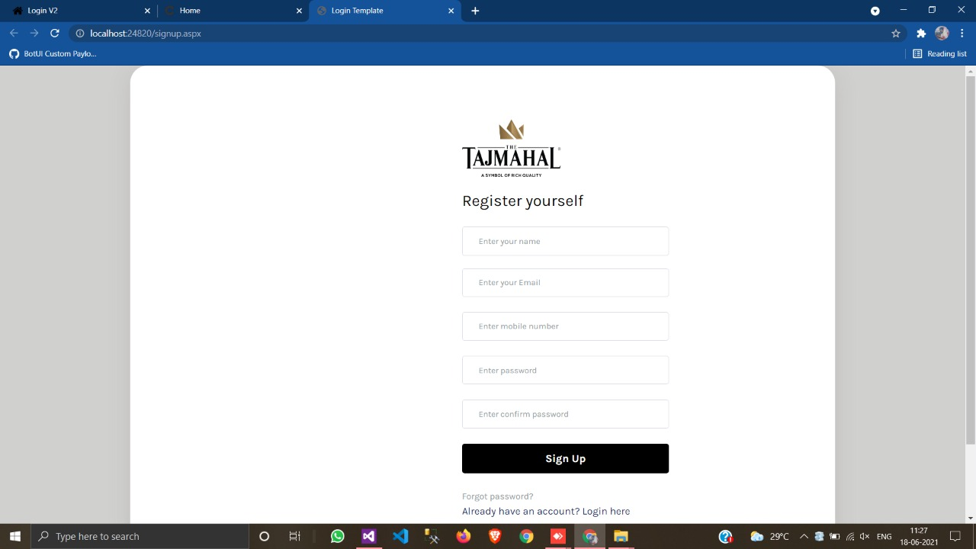

**Validations on Client Registration:**

* All the * fields are required.
* Name only alphabetic allowed.
* Email address should be in proper format.
* Mobile number only 10 digits number allowed.
* Password & Confirm Password should be same.
* It checks email address & mobile number into database if it is registered than it will not allow for new registration.

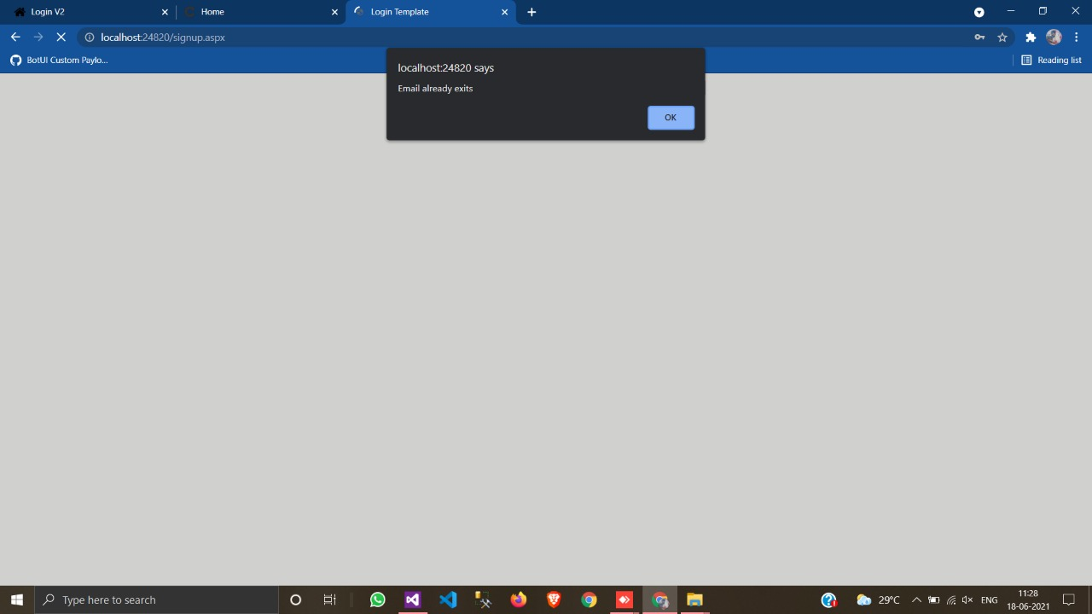

**Client Login Page**

**Validations on Client Login:**

* Username & Password are required.
* Invalid Username & Password.

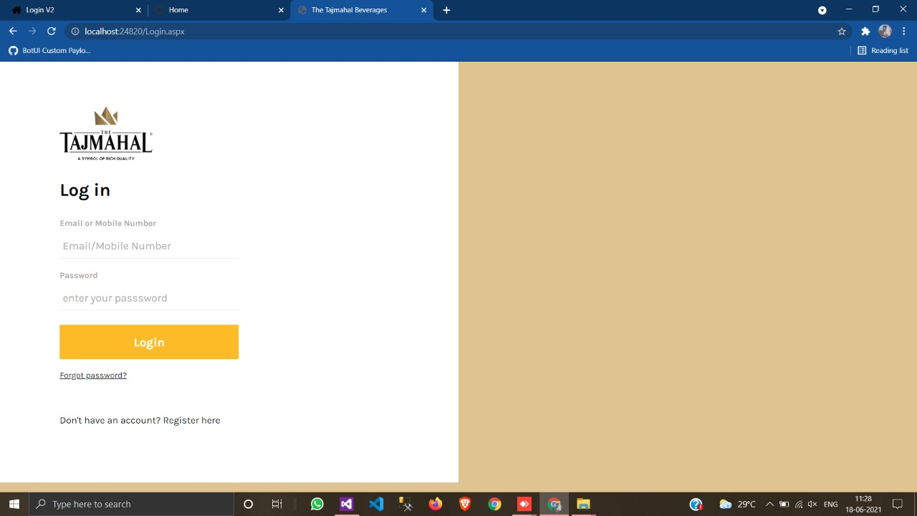

**Client Forget Password Page**

1. Insert Registered Email Address else it will give error.
2. You will receive a link on your entered email.
3. You need to click on the link, and after you need to insert

New Password & Confirm Password else the process will

be failed.

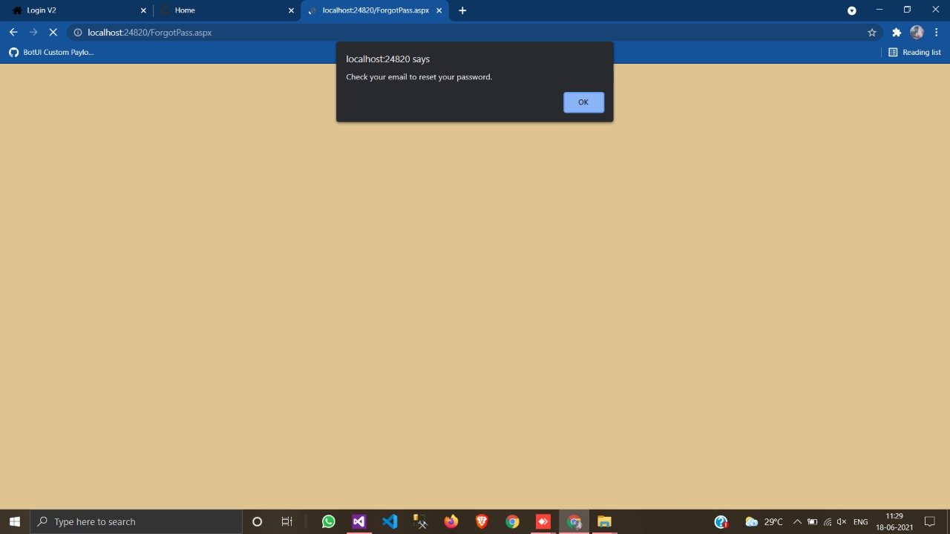

**OTP Received on Email**

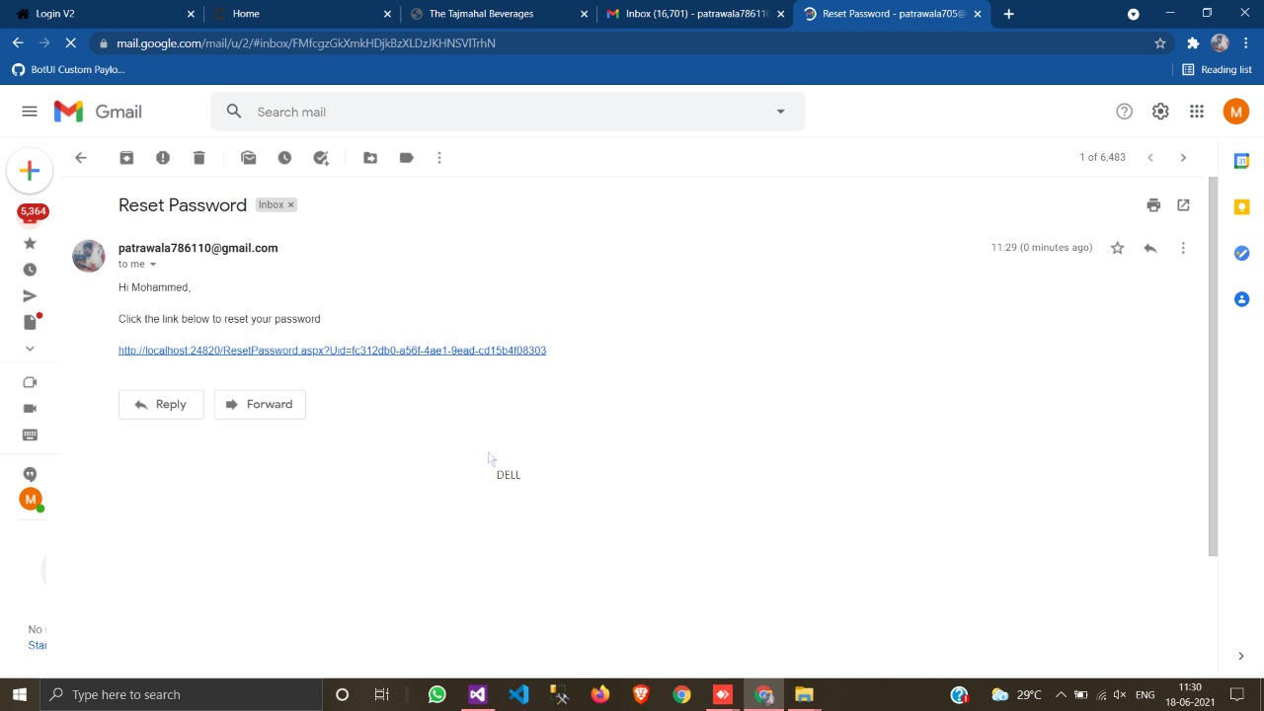

**Cart Detail Page**

* You can Add or Remove Quantity of Product or also any Product easily from the Cart Detail Page.

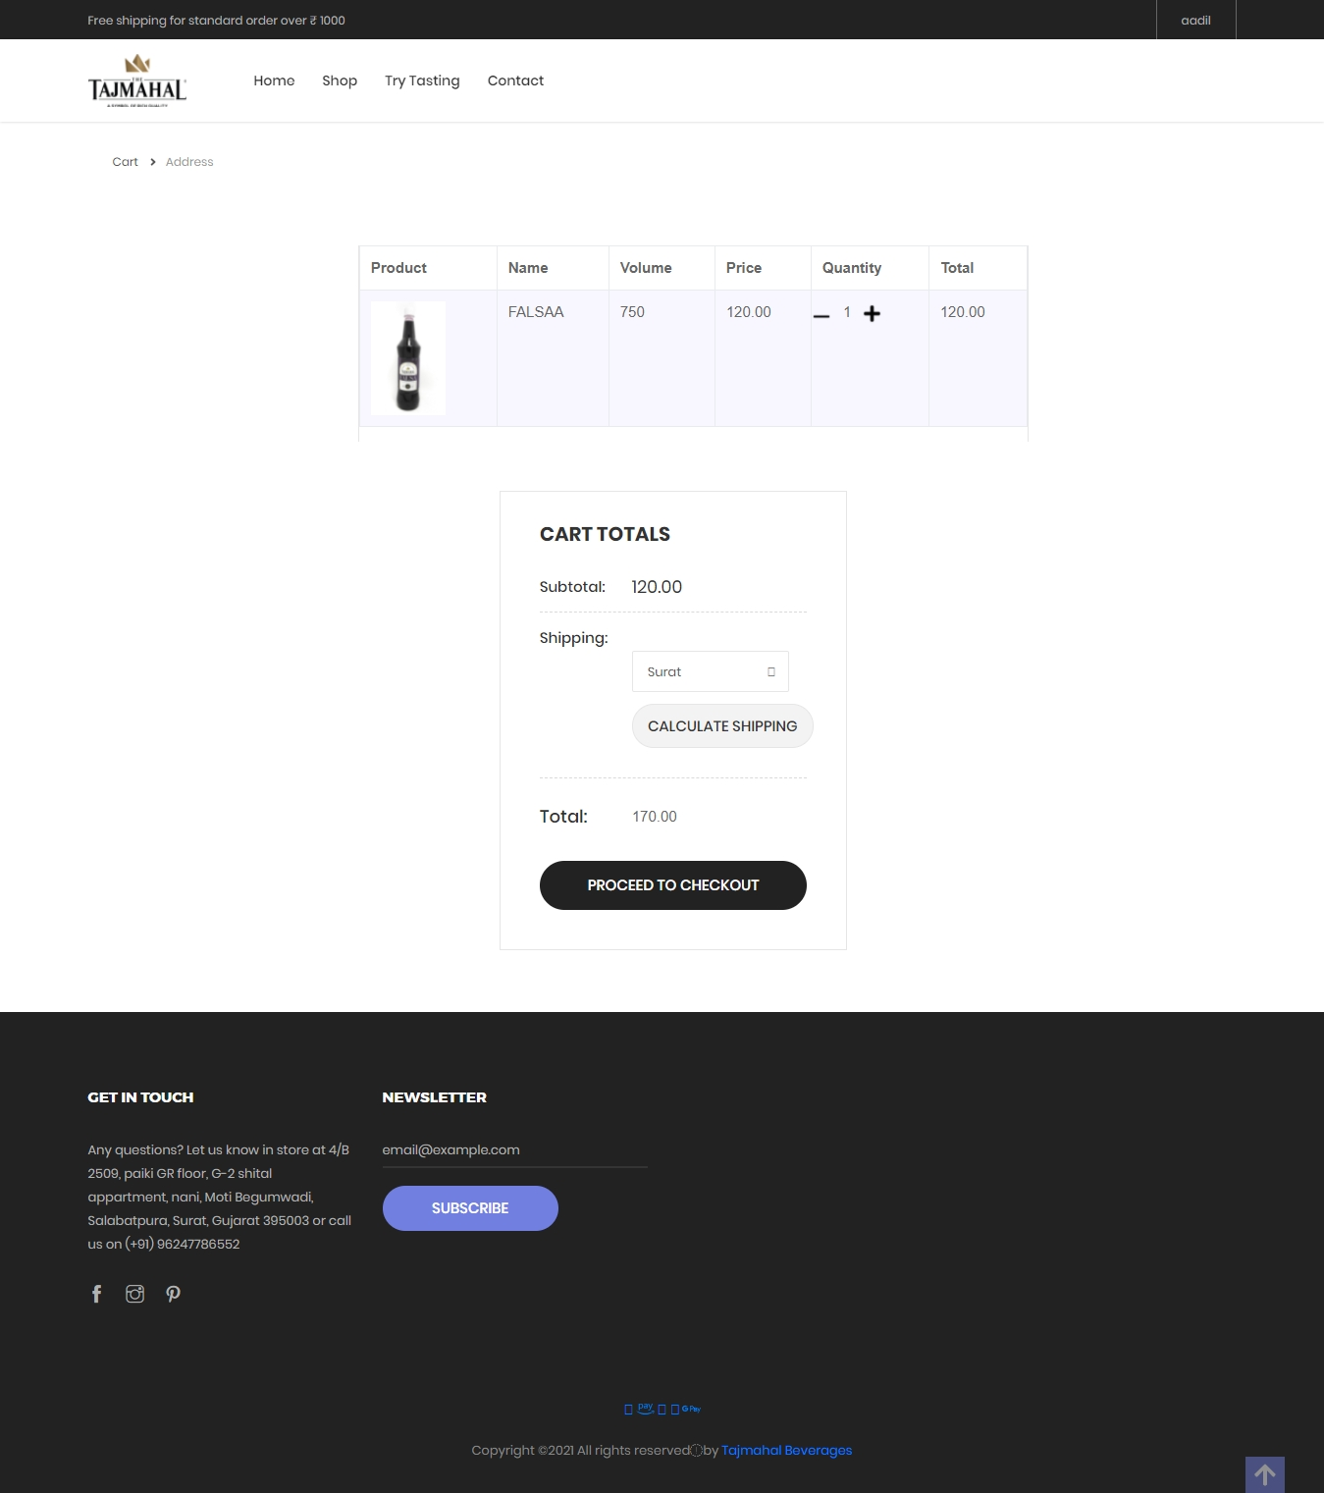

**Shipping Details Page**

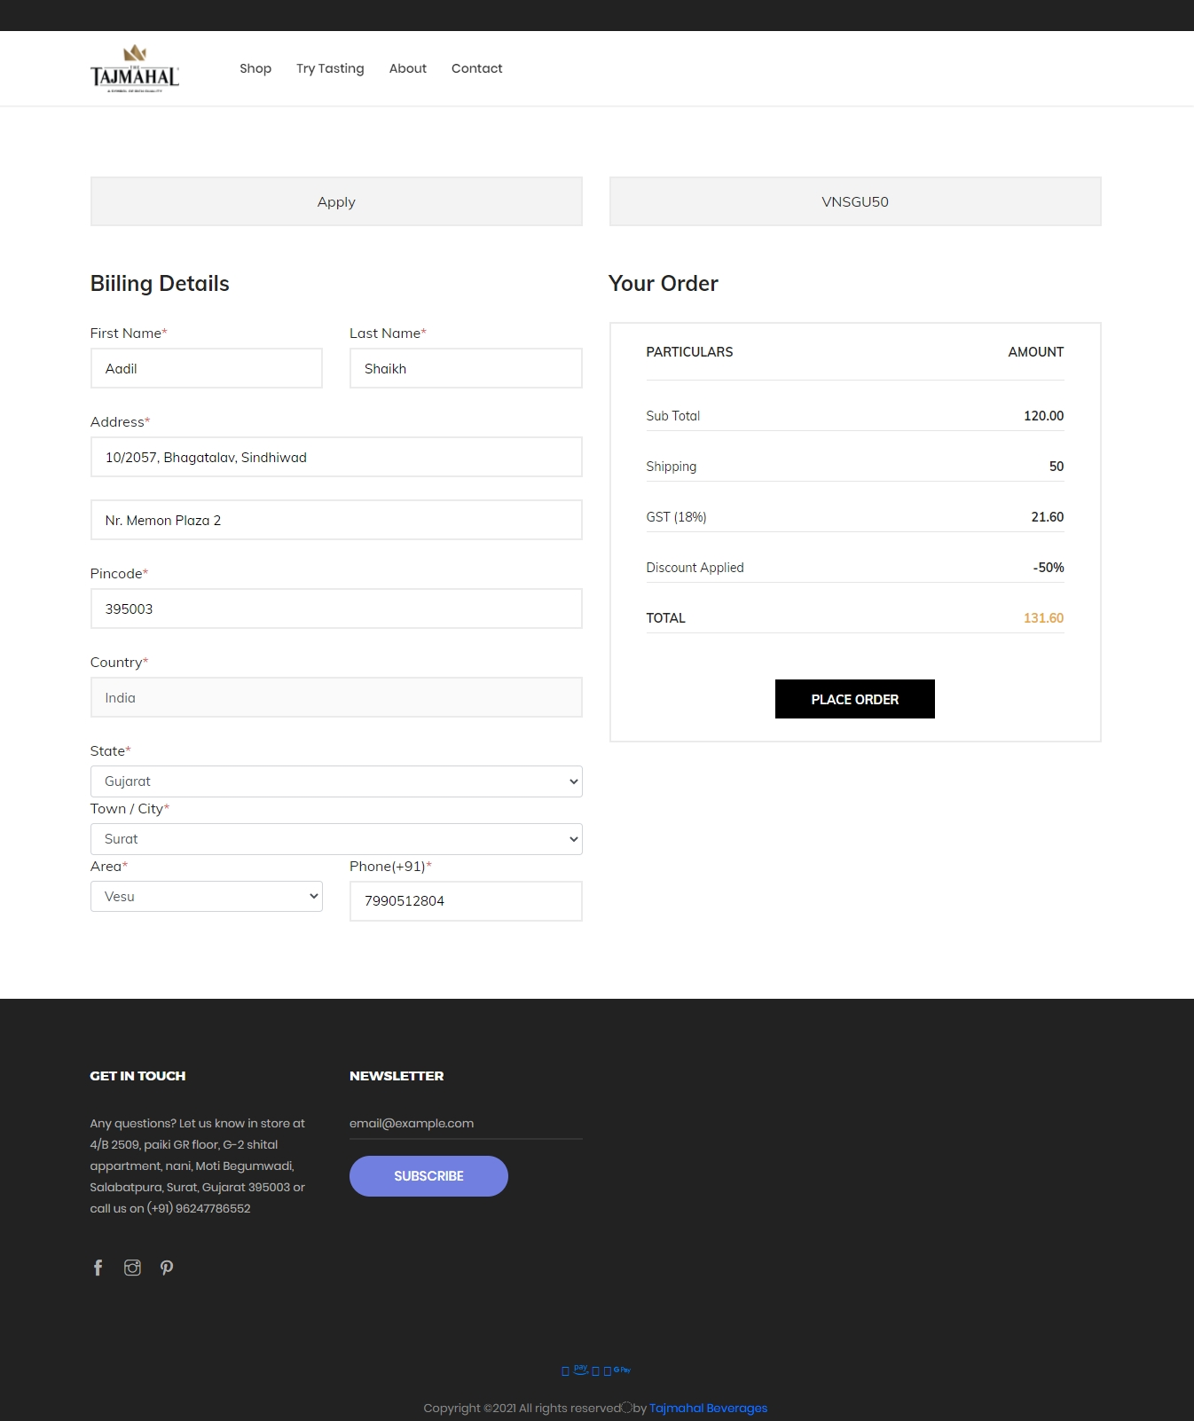

**Validation on Shipping Details Page**

* All the * fields are required.
* Phone number only 10 digits number allowed.

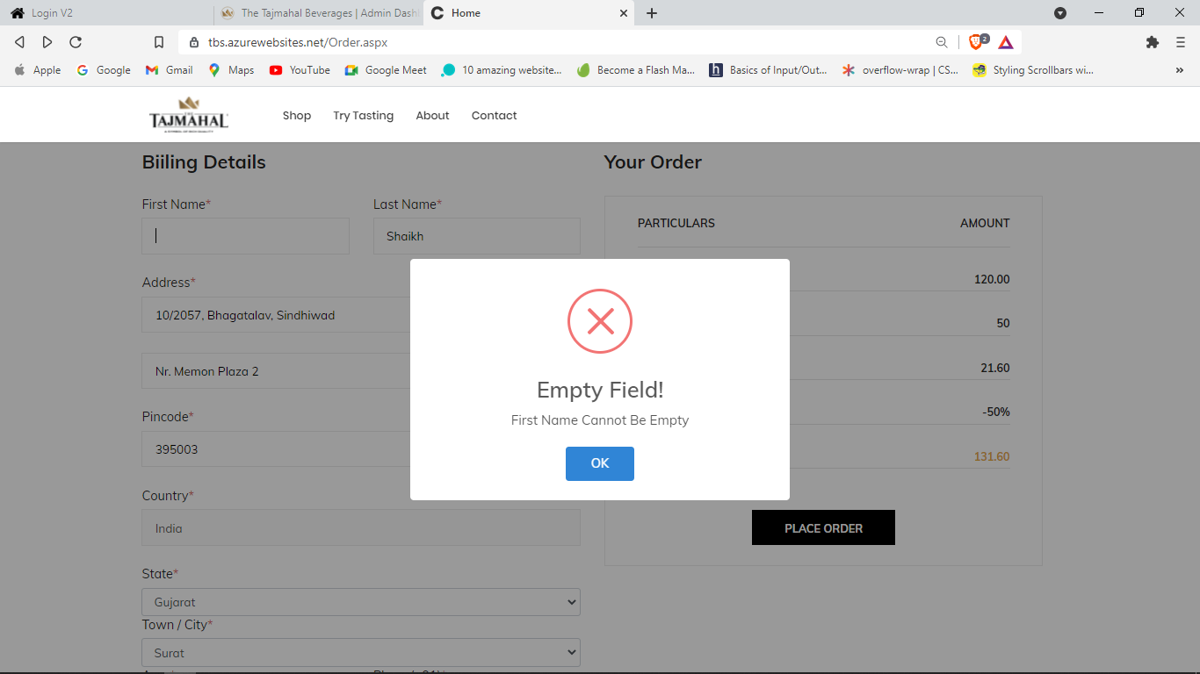

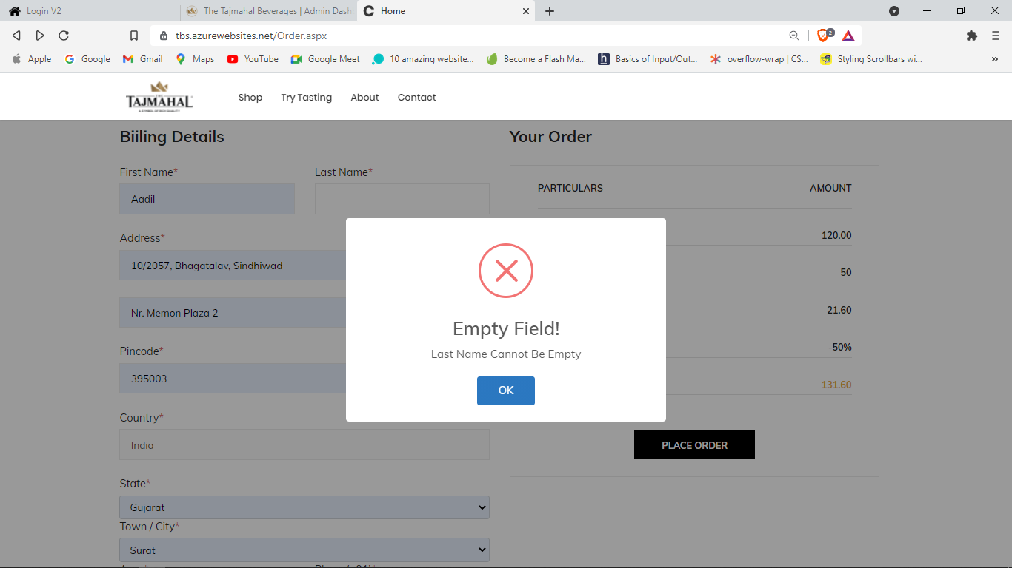

**Payment Details Page**

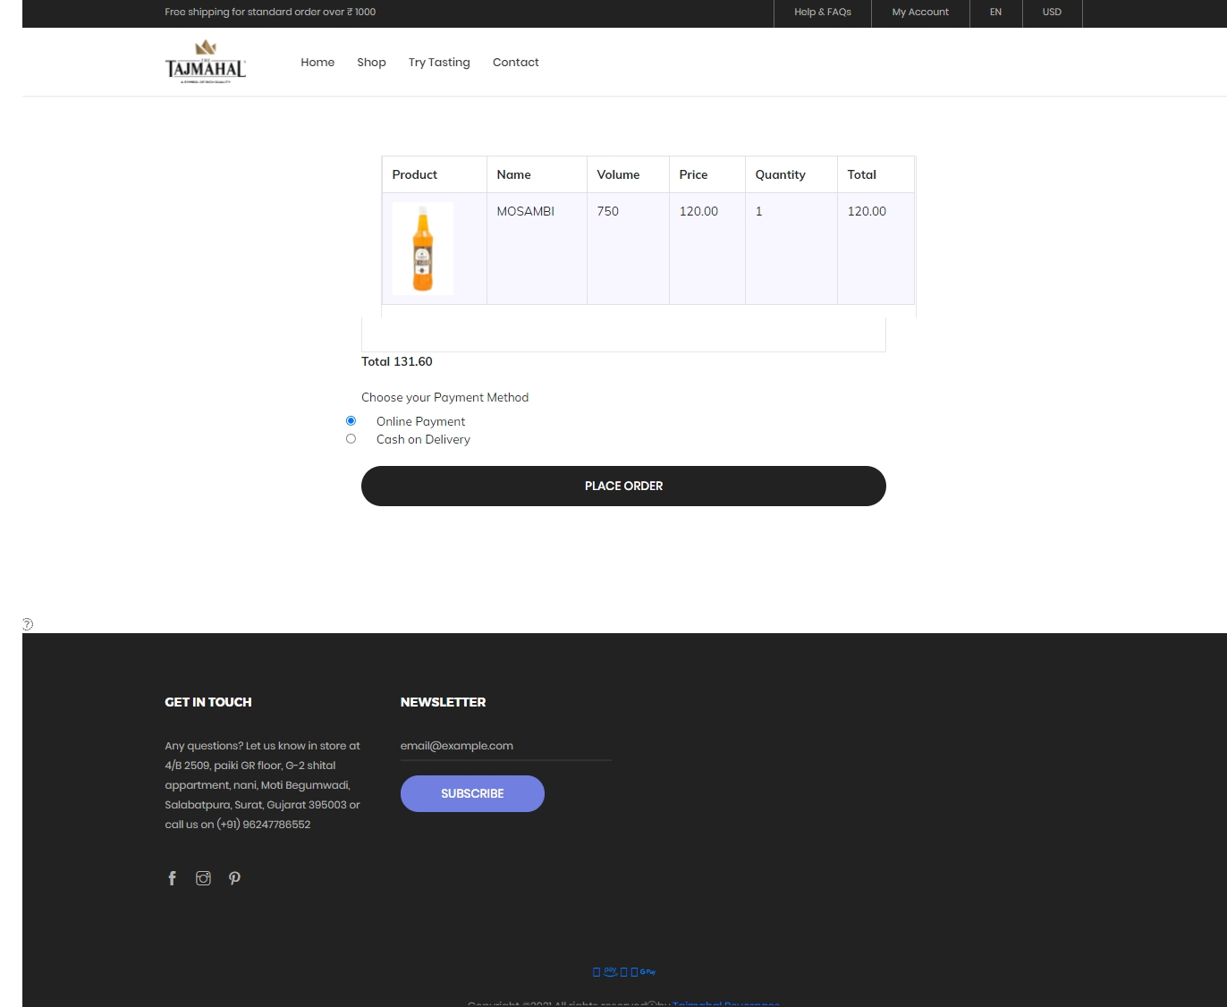

**Invoice Page**

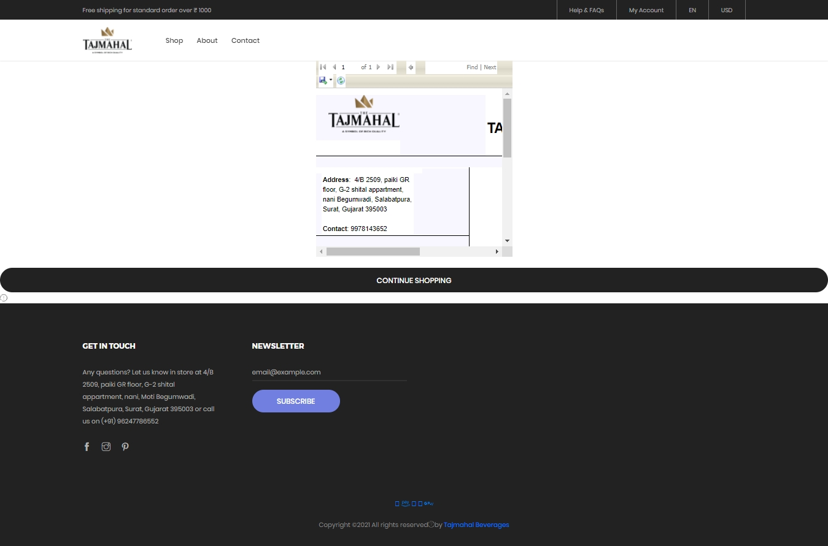

**4. Testing**

**4.1 Unit Testing**

* **Test Case for Admin Login**

|  |  |  |  |  |
| --- | --- | --- | --- | --- |
| **Test Id** | **Test Field** | **Stop Execute** | **Executed Result** | **Actual Result** |
| **1** | Username | Empty, Wrong | Invalid Username | As Expected |
| **2** | Password | Empty, Wrong | Invalid Password | As Expected |

* **Test Case for AreaMaster**

|  |  |  |  |  |
| --- | --- | --- | --- | --- |
| **Test Id** | **Test Field** | **Stop Execute** | **Executed Result** | **Actual Result** |
| **1** | AreaName | Empty,  IsExisting,  Only Character | Area Name is missing. | As Expected |
| **2** | CityId | Empty | City Name is missing. | As Expected |

* **Test Case for ProductMaster**

|  |  |  |  |  |
| --- | --- | --- | --- | --- |
| **Test Id** | **Test Field** | **Stop Execute** | **Executed Result** | **Actual Result** |
| **1** | ProductName | Empty,  IsExisting | Product name is missing. | As Expected |
| **2** | FId | Empty | Please select flavour. | As Expected |
| **3** | CatId | Empty | Please select Category. | As Expected |
| **4** | ShortDescription | Empty | Short Description is missing. | As Expected |
| **5** | MRP | Empty,  Only Digit | Insert MRP. | As Expected |
| **6** | ImagePath | Empty | Please select Image. | As Expected |
| **7** | Volume | Empty | Insert Volume. | As Expected |

* **Test Case for ShippingDetail**

|  |  |  |  |  |
| --- | --- | --- | --- | --- |
| **Test Id** | **Test Field** | **Stop Execute** | **Executed Result** | **Actual Result** |
| **1** | FirstName | Empty,  Only Character | First Name cannot be empty. | As Expected |
| **2** | LastName | Empty,  Only Character | Last Name cannot be empty. | As Expected |
| **3** | AreaId | Empty | Area Name cannot be empty. | As Expected |
| **4** | Address | Empty | Address cannot be empty. | As Expected |
| **5** | Pincode | Empty,  Only Digit | Pincode cannot be empty | As Expected |
| **6** | PhoneNo | Empty,  Only Digit | Mobile No. cannot be empty. | As Expected |

**4.2 Navigational Testing**

* **Admin**

|  |  |  |
| --- | --- | --- |
| **Link** | **Expected Page** | **Result Page** |
| **Default** | Admin Login Page | Admin Login Page |
| **Dashboard** | Admin Dashboard Page | Admin Dashboard Page |
| **State Master** | State Master Page | State Master Page |
| **City Master** | City Master Page | City Master Page |
| **Area Master** | Area Master Page | Area Master Page |
| **Category Master** | Category Master Page | Category Master Page |
| **Flavour Master** | Flavour Master Page | Flavour Master Page |
| **View Inquiry** | View Inquiry Page | View Inquiry Page |
| **Registration Master** | Registration Master Page | Registration Master Page |

* **Client & Visitor**

|  |  |  |
| --- | --- | --- |
| **Link** | **Expected Page** | **Result Page** |
| **Login** | Client Login Page | Client Login Page |
| **Home** | Home Page | Home Page |
| **Forgot Password** | Forgot Password Page | Forgot Password Page |
| **Sign Up** | Sign Up Page | Sign Up Page |
| **Shop** | Shop Page | Shop Page |
| **Product Detail** | Product Detail Page | Product Detail Page |
| **View Cart Detail** | View Cart Page | View Cart Page |
| **Wishlist** | Wishlist Page | Wishlist Page |
| **Shipping Detail** | Shipping Detail Page | Shipping Detail Page |
| **Invoice** | Invoice Page | Invoice Page |
| **Payment Detail** | Payment Detail Page | Payment Detail Page |
| **Contact Us** | Contact Us Page | Contact Us Page |

**4.3 Functional Testing**

* Functional Testing is a type of software testing where, the system is tested against the functional requirements/specifications.
* Functions are tested by feeding them input & examining the output. Functional testing ensures that the requirements are properly satisfied by the application. This type of testing is not concerned with how processing occurs, but rather, with the results of processing.
* During functional testing, Black Box Testing technique is used in which the internal logic of the system being tested is not known to the tester.
* User Registration: Process has been properly working and all fields are validated through various validation checks.
* Login & password validation process has been co-operated properly.
* Cart and Wishlist managed perfectly.
* Order is being booked safely.
* Admin side handling & dynamic & real-time data integration module is implemented successfully.
* Sending Forgot Password or Confirm Registration through mails is working properly.

**4.4 Environment Testing:**

* System Testing is a level of software testing where complete & integrated software is tested.
* The purpose of this test is to evaluate the systems compliance with the specified requirements.
* The process of testing an integrated system to verify that it

meets specified requirements.

* System Testing performed after Integration Testing & Before

Acceptance Testing.

* Normally, independent testers perform System Testing.
* Firefox browser, internet explorer & chrome consider testing for environment operability of software.

1. Web Server : IIS/Apache
2. Database : SQL Server Management Studio
3. OS : Windows 10
4. Browser : Chrome / Internet Explorer / Firefox

**5. Conclusion**

* Purpose of this website is to make the work easier for customers.
* With the help of our website, customers can find variety of Beverages and get the details of our services.
* Automation of this website improves the efficiency level.
* It is friendly graphical user interface when compared to the system

that already exists.

* It gives authentic access to the authorized users depending upon

their user type.

* It effectively overcomes the delay in communication.

**6. Bibliography**

* http:/www.w3school.com/Asp.net
* http:/www.Wikipedia.com/Asp.net
* https://www.rawpressery.com/
* http:/www.tutorialpoint.com/Asp.net
* https://www.tutorialspoint.com/asp.net/
* ASP.NET Book
* Software Engineering – A Practitioner Approach